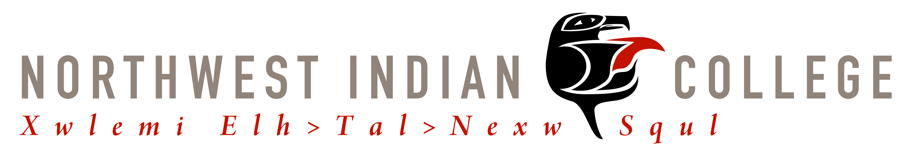



Vine Deloria Jr. Indigenous Studies Symposium Registration
July 12, 13, 14, 2012
Northwest Indian College

Bellingham, WA

Name

Address

Phone Number

Email address

Please send completed registration form and registration fee in the amount of $100.00, checks and/or money order please. Credit cards and cash will be taken on site the day of registration.
Please make checks payable to The Vine Deloria, Jr. Indigenous Studies Symposium.

Mail to:
Angel Jefferson
Vine Deloria Jr. Indigenous Studies Symposium Registration
Northwest Indian College
2522 Kwina Road
Bellingham, WA 98226

