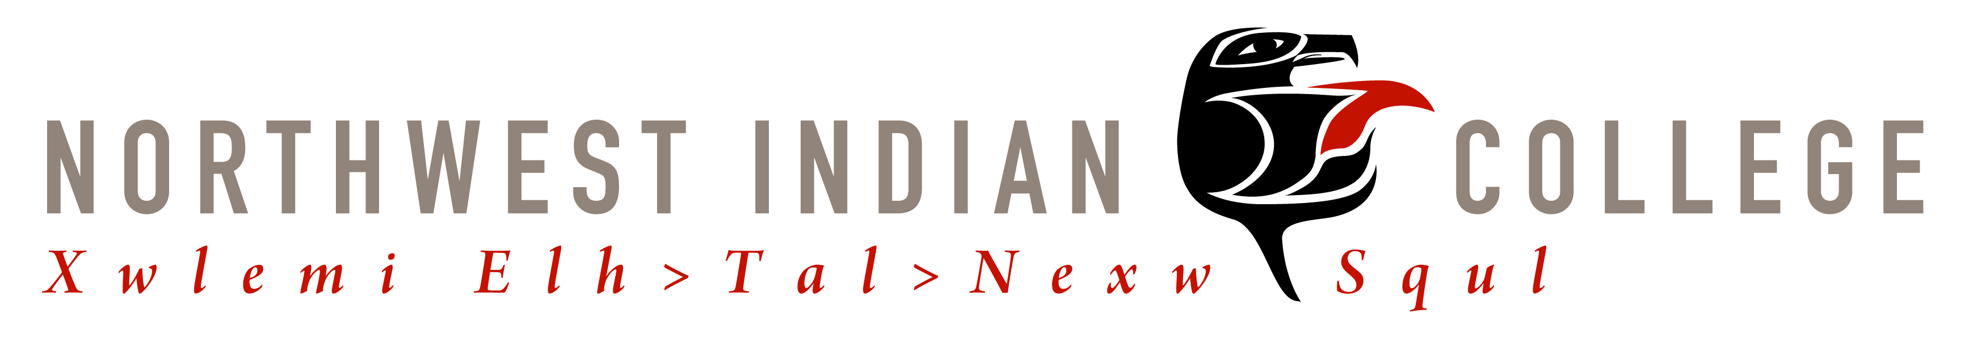



Vine Deloria Jr. Indigenous Studies Symposium Registration
July 7-9, 2011
Northwest Indian College

Bellingham, WA

Name

Address

Phone Number

Email address

Please send completed registration form and registration fee in the amount of $100.00, checks and/or money order please. Credit cards and cash will be taken on site the day of registration.
Please make checks payable to The Vine Deloria, Jr. Indigenous Studies Symposium.

Mail to:
Angel Jefferson
Vine Deloria Jr. Indigenous Studies Symposium Registration
Northwest Indian College
2522 Kwina Road
Bellingham, WA 98226

