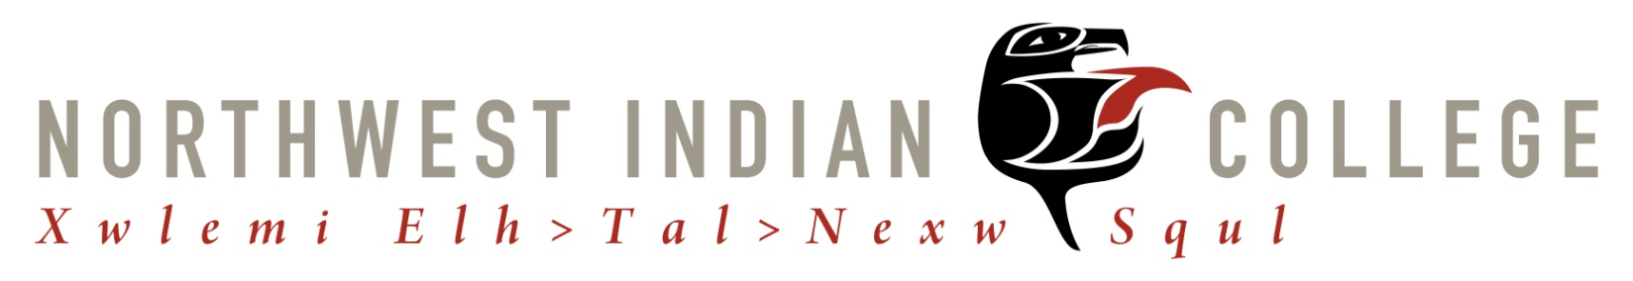
COURSE SYLLABUS

NESC 110: INTRODUCTION TO NATIVE ENVIRONMENTAL SCIENCE

Instructor: TBD  Office: TBD  Hours: TBD  Email: TBD  Phone: TBD | Quarter: TBD  Credits: 1  Days/Times: TBD  Room: TBD

Catalog Course Description

Introduction to fundamental Native science principles and concepts. Provides an initial understanding of the intimate relationship between Native people and the natural world. Designed for students interested in a career in the field of environmental science and newly declared Native Environmental Science students.

Course Materials
- Readings found on Canvas
- 1 notebook for class notes
NWIC Outcomes
As a result of this class, students will be able to:
- Demonstrate a sense of place.
- Demonstrate an understanding of what it is to be a people.

Course Outcomes
As a result of taking this course, students will be able to:
- Describe sense of place and be able to self-locate
- Define Native Science
- Demonstrate an understanding of multiple ways of knowing and the rationality between people, place, and tribal application of knowledge.
- Evaluate current environmental issues in relation to the needs of tribal communities.

Course Requirements
- Class Attendance: Regular participating and attendance at lectures are essential to your success in this course. It is your responsibility to attend class. Necessary absences should be reported to your instructor, more than two unexcused absences may result in a grade reduction that will prevent you from passing this course.

- Readings/Discussions: This is a discussion-based class. Participation is a key component of both student learning and grades. Students will be graded on their weekly participation and discussions in the classroom and with the coursework. Students are expected to come to class having read the material and ready with questions and insights to share. Please refer to the “Reading List” and Weekly Canvas Modules for the reading assignments and materials. To successfully complete the assignments and complete in class discussion, you will need to read all required readings. Please come prepared!

- Annotated Bibliography: Students will write annotated bibliography entries for all books and articles in the course. All students will submit a two-paragraph annotated bibliography. Please use one paragraph to summarize the reading and the second paragraph to briefly describe what was interesting and how it is relative to your studies.

- Final Research Project: This course cumulates in a final project conducted by the student. Students will develop a research project to address an environmental concern in their community that incorporates Native Science.

- Canvas and Email: I will use your NWIC email address to communicate with you in this course, please access and become familiar with your NWIC email.

Plagiarism Warning
All student work must be original in order to gain credit. Using anyone else’s words, phrases, sentences, paragraphs, etc. without citation is plagiarism. If you cut and paste anything at all from a website for example, without putting quotation marks around it and citing it, that is plagiarism. Plagiarism is cheating. If you have any doubt at all about what constitutes plagiarism, please ask. Plagiarism usually occurs when a student feels overwhelmed for some reason (assignments to heave; family or relationship problems; financial worries, etc.). If this should happen to you, please let me know, and we will work out something that will be a lot more beneficial to you than cheating.

GRADING: Letter grading will be used for this course.

A – 100-90%  B – 89 – 80%  C – 79-70%  D – 69 – 60%  F – 59 – 0% | Participation: 40%  Attendance  In class Participation  Assignments: 60%  Annotated Bibliography  Final Project

Note: This syllabus is meant to be a general guide for class. It is not a "contract." As the course moves forward, I may add, change, or delete readings. You will be notified if and when any change is made and provided with an edited weekly schedule if necessary.

Weekly Schedule

Week 1 Introduction

Week 2 Sense of Place

Week 3 Native Science

Week 4 Traditional Ecological Knowledge

Week 5 Indigenous Research Paradigm

Week 6 Mid-term Abstracts and Short-Presentations Due

Week 7 Food Sovereignty

Week 8 Sacred Places

Week 9 Governance of Shared Resources

Week 10 Environmental Ethics

Week 11 Native Environmental Law

Week 12 Applying Native Science

* See Canvas for assignments, readings and due dates. All assignments are to be submitted by due dates posted on Canvas or in some cases by agreement with the instructor. Grades will be posted to Registrar's Office by the end of finals week.

