Current Definition of Grades

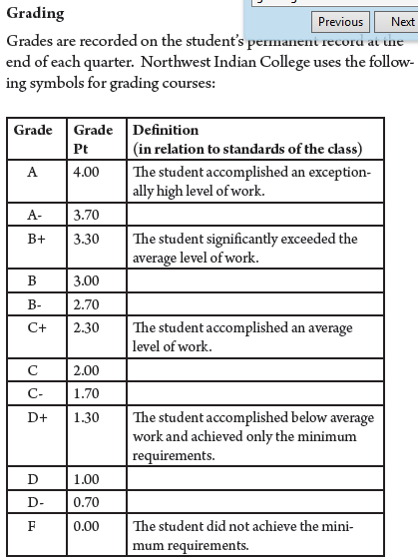

Updated 3/10/15

A: The student has met or exceeded the highest level of the course requirements
B: The student has demonstrated work above the satisfactory level of the course requirements
C: The student has met the course requirements at a satisfactory level
D: The student has met some but not all of the course requirements
F: The student has not met the course requirements

The course requirements and the levels of accomplishment will be clearly defined in the course syllabus

