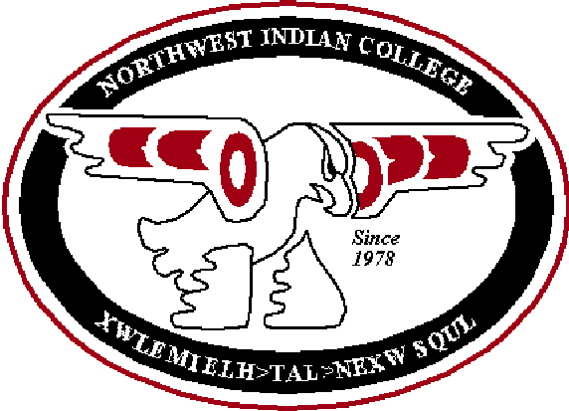
Course Outcomes Form

Northwest Indian College
Hand-outs are posted on the Assessment website (http://ww2.nwic.edu/faculty/assessment/assessment.htm)

Before completing this form, please refer to the Instructions for Completing the Course Outcomes Form. Please submit this form electronically.
It is important to keep the following principles in mind when completing the forms:
- Regardless of the mode of learning (i.e., face-to-face, Independent learning, ITV, online, etc.) or the location of a course, only one course outcomes form should be completed for each course.
- Regardless of the mode of learning or the location of a course, the NWIC outcomes and the Course outcomes must be the same for a course.
- The Instructional activities and the Assessment/evaluation strategies may differ depending on the mode of learning. Please note Instructional activities and the Assessment/evaluation strategies that are different from the face-to-face class in each box (e.g., “IL: Essay”).

Last date this form was updated or edited | 10/3/12
Course Number (e.g., ENGL 101) | TGBM 499 A&B
Course Name (e.g., English Composition I) | Capstone Project
List all instructor(s) who participated in creating and approved these course outcomes (please consult with at least one other person) | Laural Ballew, Steve Zawoysky, and Don Mccluskey
List the main textbooks, readings or other resources used in this course (including title, year and publisher) | Research Methods in Public Adminsitration and Nonprofit Management – McNabb, David E., 2002, M.E. Sharpe. ISBN: 0765609576
 | Additional research and readings

A. NWIC outcomes: From the List of NWIC Outcomes, select the most important outcomes you assess in this course (at least one NWIC outcome must be chosen- maximum of four).

NWIC outcome # (e.g., “Written communication: 2a. Write Standard English”) | Instructional Activities: How will students master this outcome? (e.g., solving problems, group activity) | Assessment/Evaluation Strategies: How will you measure this outcome? (e.g., student presentations, essays)
Written Communication: Write standard English | -writing assignments, use of portfolio component  -Final Written Capstone Project | -Written capstone project rubric
Write in a variety of text forms using various credible sources | -study of research and analyzing techniques, writing assignments and the use of case studies. | -Written assignments rubric and capstone project rubric
Oral Communication: Apply effective presentation skills | -Oral presentation of Capstone Project | -Oral capstone project presentation rubric

B. Course outcomes: In order of priority, list the most important other learning outcomes for this course that you assess (a maximum of 10).
Other course outcomes: Complete the sentence –  As a result of this course, students will be able to… | Instructional Activities: How will students master this outcome? (e.g., solving problems, group activity) | Assessment / Evaluation Strategies: How will you measure this outcome? (e.g., student presentations, essays)
Approach, critique, analyze, communicate and utilize research | Course material, lecture and research | Written and oral Capstone project grading rubrics
Create a written and oral presentation regarding a specific topic of their choice related to the area of study in Tribal Governance and Business Management | Research methodology and analytical techniques used in course materials and lectures. | Written and oral Capstone project grading rubrics
Students will demonstrate concise knowledge of the selected area of discipline specific the topic | Research methodology and analytical techniques used in course materials and lectures | Written and oral Capstone project grading rubrics

C. Please list the NWIC outcomes and course outcomes from above on your syllabus.

D. Please assess the NWIC outcomes and course outcomes, which are listed above, in your classes.

