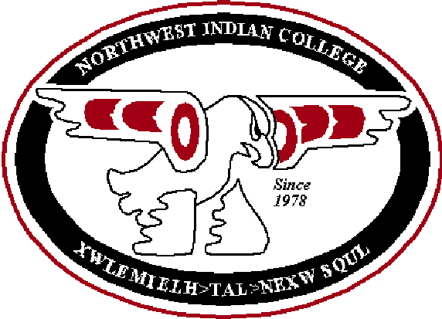
Course Outcomes Form

Northwest Indian College
Hand-outs are posted on the Assessment website (http://ww2.nwic.edu/faculty/assessment/assessment.htm)

Before completing this form, please refer to the Instructions for Completing the Course Outcomes Form. Please submit this form electronically.
It is important to keep the following principles in mind when completing the forms:
- Regardless of the mode of learning (i.e., face-to-face, Independent learning, ITV, online, etc.) or the location of a course, only one course outcomes form should be completed for each course.
- Regardless of the mode of learning or the location of a course, the NWIC outcomes and the Course outcomes must be the same for a course.
- The Instructional activities and the Assessment/evaluation strategies may differ depending on the mode of learning. Please note Instructional activities and the Assessment/evaluation strategies that are different from the face-to-face class in each box (e.g., “IL: Essay”).

Last date this form was updated or edited | 10/3/12
Course Number (e.g., ENGL 101) | TGBM 310
Course Name (e.g., English Composition I) | Human Resources in Native Communities
List all instructor(s) who participated in creating and approved these course outcomes (please consult with at least one other person) | Laural Ballew, Steve Zawoysky
List the main textbooks, readings or other resources used in this course (including title, year and publisher) | A Guide to Tribal Employment: An Employment guide for tribal council, human resources, and enterprise officials – Mcgee, Richard. Xlibris publishing, 2008. ISBN: 1436375274
 | Additional readings provided by instructor

A. NWIC outcomes: From the List of NWIC Outcomes, select the most important outcomes you assess in this course (at least one NWIC outcome must be chosen- maximum of four).

NWIC outcome # (e.g., “Written communication: 2a. Write Standard English”) | Instructional Activities: How will students master this outcome? (e.g., solving problems, group activity) | Assessment/Evaluation Strategies: How will you measure this outcome? (e.g., student presentations, essays)
Written Communication: 2a. Write standard English | -Readings, discussions, and assignments  -Written Personal Code of Ethics | -Assignments and tests  -Personal Code of Ethics Rubric
Reading Skills: 6b. Extend their own vocabulary through reading. | -Assigned research and readings | -Quizzes and tests

B. Course outcomes: In order of priority, list the most important other learning outcomes for this course that you assess (a maximum of 10).
Other course outcomes: Complete the sentence –  As a result of this course, students will be able to… | Instructional Activities: How will students master this outcome? (e.g., solving problems, group activity) | Assessment / Evaluation Strategies: How will you measure this outcome? (e.g., student presentations, essays)
Distinguish employment law practices depending on jurisdiction | -Text readings, case studies, and discussion on jurisdictional differences in employment law | -Assignments, quizzes, and tests
Identify best practices in human resources | -Readings, discussions, and cases | -Assignments, quizzes, and tests  -Case Study Project
Compare and contrast tribal employment dispute resolution procedures | -Readings, discussions, assignments and cases | -Case Study Project  -Assignments, quizzes, and tests
Evaluate the impact of gaming enterprises on tribal employment practices | -Readings, discussions, cases, and assignments | -Assignments, quizzes, and tests

C. Please list the NWIC outcomes and course outcomes from above on your syllabus.

D. Please assess the NWIC outcomes and course outcomes, which are listed above, in your classes.

