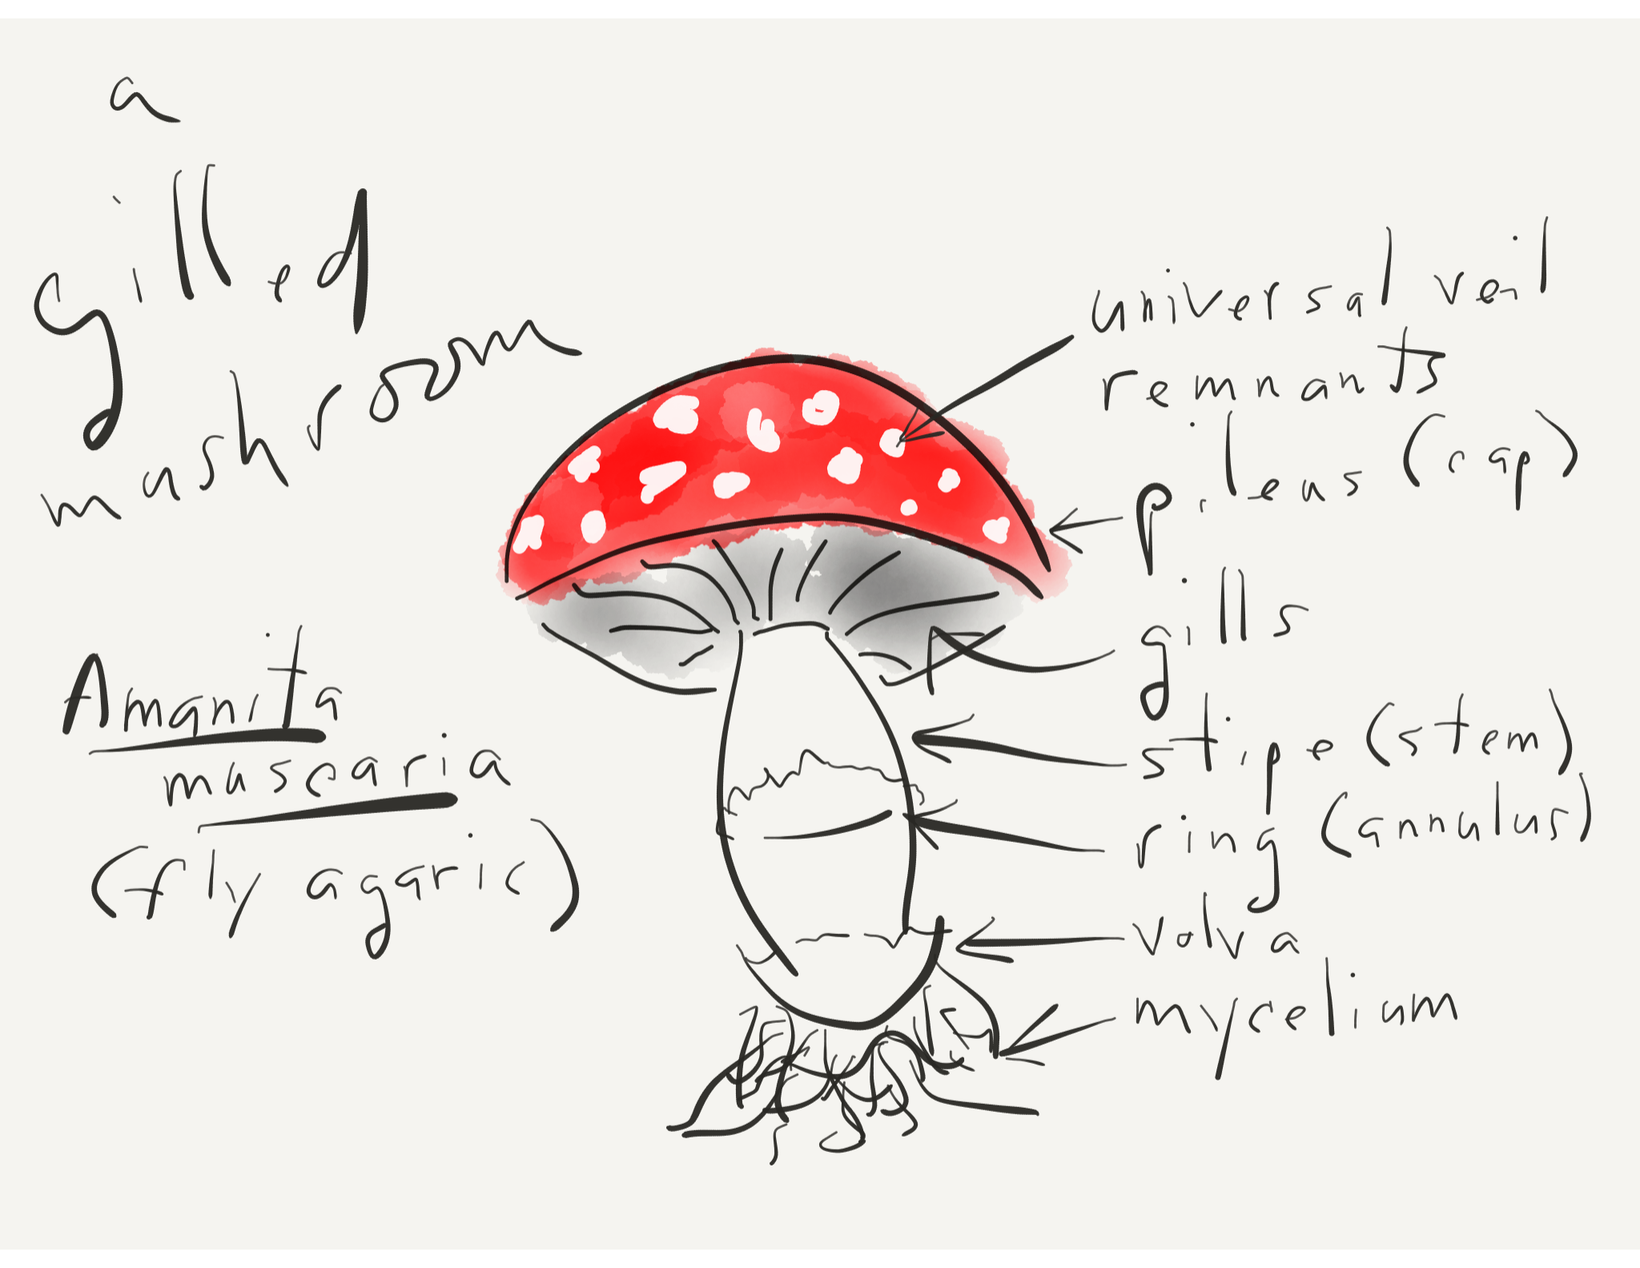
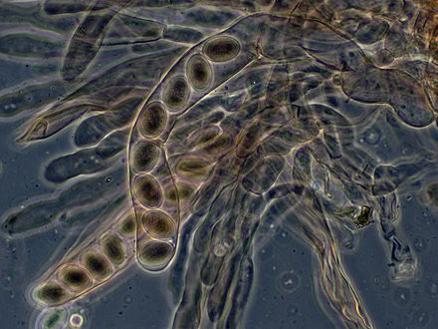
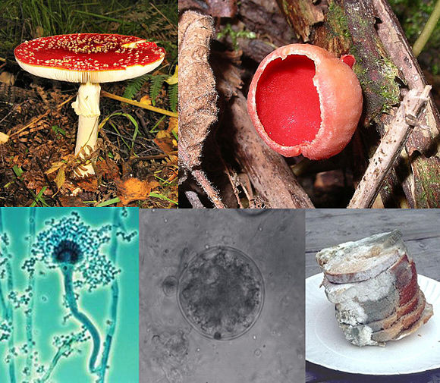

Werner (2008)
BorgQueen (2009)

Course BIOL 450 Mycology (5 credits)
Meeting Details As indicated in the NWIC online class schedule

Instructor Information
Instructor: Brian D. Compton, Ph.D.
Office Location: Kwina Office/Classroom Complex #110 (in Building 15)
Office Hours: As posted and by appointment
Telephone/Fax: (360) 392-4321
Email: bcompton@nwic.edu
Canvas Login: https://nwic.instructure.com/login/ldap
Contents
Course Description 2
Prerequisites 2
Course Fee 2
Course Outcomes 2
Course Materials 2
Required Text 2
Online Support 2
Outline/Schedule of Topics and Assignments 3
Evaluation and Assessment—Requirements, Assignments, and Grading 5
Requirements and Assignments 5
Grading 6
Appendix: Additional Syllabus Information 7
Disclaimer 7
Philosophy Statement 7
Purpose Statement 7
Course Overview 7
Recommended Readings 8
Optional Course Materials and Resources 9
Course Policies 10
Science Writing Mentor Information 10
Additional Important Details Regarding Grading 10
Lummi Beliefs 11
Institutional and Program Outcomes 12
Rubric 13
References 13

Course Description

Overview of mycology and the relationship of fungi to environmental and human affairs with primary emphasis on Indigenous Peoples and the Pacific Northwest. Topics include cultural significance of fungi among Indigenous Peoples; biology, diversity, nomenclature and taxonomy of fungi; ecological significance of fungi; and collection and identification of local funga.

Prerequisites

ENGL 102 English Composition II and ENVS 201 Northwest Plants.

Course Fee

This course may include a fee for laboratory materials.

Course Outcomes

As the result of this course students will be able to …
- Describe in biological terms the primary characteristics of fungi and associated organisms, which reflect their unique attributes and relationships to each other and to non-fungal organisms.
- Indicate how local fungi may be identified based on their biological and ecological characteristics.
- Collect and identify local fungi in accordance with established mycological methods.
- Discuss examples of traditional cultural significance of fungi among Indigenous Peoples of the Pacific Northwest.
- Discuss the significance of fungi as related to aspects of contemporary environmental and human affairs with emphasis on Indigenous Peoples of the Pacific Northwest.

Course Materials

Required Text
Moore, D., Robson, G. D., & Trinci, A. P.J. (2016, December). 21st century guidebook to fungi. Retrieved from http://www.davidmoore.org.uk/21st_Century_Guidebook_to_Fungi_PLATINUM/index.htm
[This is an online interactive ebook, which includes all the chapters in Moore, Robson, & Trinci (2011) with updates as of December 2016.]
Required Fieldwork and Lab Tools and Materials
- Plastic containers or paper collection bags (but not plastic bags)
- Field journal
- Paper for lecture notes and lab illustrations
- Pencil or pen (colored pencils are good for making enhanced illustrations, if desired)
- Clothing and footwear as appropriate for environmental conditions encountered during field trips
- Fungus collection tool (to collect subterranean fungal structures, e.g., garden trowel)
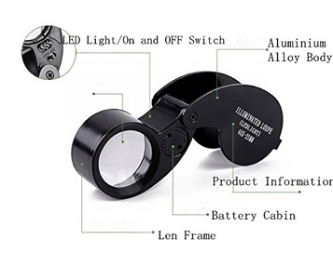
- Hand lens or loupe (e.g., 40x 25mm illuminated – see illustration below)

Online Support
This course is supported by a Canvas course site (see above under Instructor Information). In the event of an unscheduled college closure, check the Canvas course site for assignments and updates so that you may continue your academic progress outside of class.

Outline/Schedule of Topics and Assignments

Week 1
BEFORE: Ancient Indigenous Mycological Knowledges
- Course Introduction
- Syllabus
- Topics and Materials:
  - Recommended reading (see appendix)
  - Ethnomyological Considerations of Local Funga
- Lab:
  - Introduction to collection and identification of local funga utilizing microscopy, taxonomic keys, field guides, and other resources
  - Northwest Mushroomers Association Event(s)
- Assignments:
  - Pre-course knowledge survey
  - Class project
  - Formal paper (or alternative course product)
- Due: Pre-course knowledge survey at 5:00 pm on Friday

Week 2
BEFORE: The Ancient Geologic Past; Fungi Origins, Evolution, and Fossils
- Topics and Materials:
  - Recommended reading (see appendix)
  - Paleomycological Considerations of Fungi and Lichens
- Lab: Collection and identification of local funga
- Assignments:
  - Class project
  - Formal paper (or alternative course product)

Week 3

BEFORE—THE RECENT PAST: History and Development of Mycology
- Topics and Materials:
  - Recommended reading (see appendix)
  - History and Development of Mycology
- Lab: Collection and identification of local funga
- Assignments:
  - Class project
  - Formal paper (or alternative course product)

Week 4
PRESENT: Current Status of Mycology
- Topics and Materials:
  - Recommended reading (see appendix)
  - Survey of Fungi
  - Mycological Classification, Nomenclature, and Biodiversity
  - Fungi and Fungi Analogues: Summary of Taxonomy and Characteristics
- Lab: Collection and identification of local funga
- Assignments:
  - Class project
  - Formal paper (or alternative course product)

Week 5

PRESENT: Fungi and Human Affairs
- Topics and Materials:
  - Recommended reading (see appendix)
  - Survey of Fungi, continued
  - Mycophagy and Fungi in Food Processing
- Lab: Collection and identification of local funga
- Assignments:
  - Class project
  - Formal paper (or alternative course product)

Week 6
PRESENT: Fungi and Human Affairs
- Topics and Materials:
  - Recommended reading (see appendix)
  - Survey of Fungi, continued

- Lab:
  - Collection and identification of local funga
  - Special Event: Northwest Mushroomers Association 2018 Wild Mushroom Show (Sunday, October 21, 12-5 pm, Bloedel Donovan Community Building, Bellingham, WA)
- Assignments:
  - Class project
  - Formal paper (or alternative course product)
- Due: Mid-term knowledge survey at 5:00 pm on Friday

Week 7
- Topics and Materials:
  - Recommended reading (see appendix)
  - Survey of Fungi, continued
- Lab: Collection and identification of local funga
- Assignments:
  - Class project
  - Formal paper (or alternative course product)

Week 8
- Topics and Materials
  - Recommended reading (see appendix)
  - Survey of Fungi, continued
- Lab: Collection and identification of local funga
- Assignments:
  - Class project
  - Formal paper (or alternative course product)

Week 9
PRESENT AND FUTURE: Further Mycological Knowledge Building and Applications
- Topics and Materials:
  - Recommended reading (see appendix)

  - Fungal Molecular Genetics and the Future of Mycology
  - Practical Aspects and Applications of Fungi in the Home and Garden
- Lab: Collection and identification of local funga
- Assignments:
  - Class project
  - Formal paper (or alternative course product)
- Due: Draft formal paper (or alternative course product) at 5:00 pm on Friday

Week 10
- Topics and Materials:
  - Recommended reading (see appendix)
  - Mycoremediation
- Lab: Collection and identification of local funga
- Assignment: Class project

Week 11
- Topics and Materials: Development of class project
- Lab: Completion of class project
- Due: Final formal paper (or alternative course product) at 12:00 pm on Friday

Week 12
- Presentation of final student work
- Lab: Completion of class project
- Assignments:
  - Final knowledge survey on approved course outcomes
  - Self-assessment of learning
- Due: Class project at 12:00 pm on the last day of the quarter
- Due: Final knowledge survey at 12:00 pm on the last day of the quarter
- Due: Self-assessment of learning at 12:00 pm on the last day of the quarter

Evaluation and Assessment—Requirements, Assignments, and Grading
In this course, I will use the term evaluation (which may also be referred to as summative assessment) to refer to the process of reviewing students' course requirements and assignments for the purpose of determining their value as related to a standard (such as one or more course rubrics) and to determine the grade students have earned as indicated below. I will also engage in formative assessment for each student with the goal of providing ongoing feedback that I and students may use to improve our teaching and learning ("Whys and Hows," n.d.). In addition, I may be requested to review the overall results of this course for the purposes of Bachelor of Science in Native Environmental Science program assessment. This latter assessment has no impact on the grade you will earn in this course but has the goal of improving this course and that program. Finally, self-assessment of student learning is included in this course, which may include student engagement in self-reflection and metacognition (i.e., thinking about one's thinking) to determine not only what students have learned but how they have learned it with a view to improving their learning strategies in the future (Gooblar, 2015, cf. Rolheiser & Ross, 2013). A potential additional goal of self-assessment is to help students be better equipped to provide feedback on this course and my efforts.

Requirements and Assignments
Note: This course is based on a total of 100 possible points, including elements as indicated below.
- Attendance and Participation (0 points or 0% of final grade)
Attendance will be recorded and reported to Enrollment Services for financial aid purposes but will not contribute points for grading purposes. That being said, attendance and participation are essential to the successful completion of this course.
- Pre-course Knowledge Survey (5 points or 5% of final grade)
This is a brief written assignment to address the approved course outcomes. Complete assignments that address each course outcome will receive all the possible points.
- Mid-term Knowledge Survey (15 points or 15% of final grade)
This will involve student work regarding learning with a focus on course outcomes up to the mid-term.
- Final Knowledge Survey (20 points or 20% of final grade)
This will involve student work regarding learning with a focus on course outcomes up to the end of the term.
- Class Project Part A—Checklist of Local Funga (5 points or 5% of final grade)
This will consist of a group effort regarding a final list of all fungal species observed, collected, and identified during the term.
- Class Project Part B—Course Product on Local Funga (25 points or 25% of final grade)
This will consist of a group effort to create a course product on local funga for presentation at the end of the term. It may take different forms, based upon student interest.
- Final Formal Paper (25 points or 25% of final grade)
Formal written research reports consist of seven (7) pages, not counting the separate title page, abstract page, and references section. They should include a minimum of four (4) references. These are to be produced in accordance with APA (American Psychological Association) Style guidelines, submitted in electronic form, and to address editorial review and feedback to be eligible for full credit. They will be evaluated according to the corresponding rubric presented in the appendix to this syllabus. Complete assignments will receive all the possible points. Note: An assignment template is available from the instructor.) Alternative course products, such as posters, also may satisfy this course requirement. Please consult with the instructor for details.
This assignment may take various forms. For example, students may choose to research, write on, and present on various mycological topics, or they may choose to address a topic using a monographic approach, to be further defined in class.
Students should seek to address one or more course outcomes in this assignment.

- Self-assessment of Learning (5 points or 5% of final grade)
This should consist of a written report on 1) what you consider to be important knowledge and skills that you gained from this course, 2) what you regard as positive efforts on your part that have contributed to your success in this course, 3) details regarding the extent and quality of your efforts towards any collaborative student work, 4) limiters or barriers to your attainment of course learning outcomes, and 5) details regarding the grade you believe you earned in this course. This assignment does not need to comply with APA Style guidelines and is not subject to editorial review and feedback.

Grading
Note that students must complete course requirements as described in this syllabus to be eligible for receiving a grade for this course. Northwest Indian College uses the following symbols for grading courses:
      - A: The student has met or exceeded the highest level of the course requirements.
      - B: The student has met the course requirements above the satisfactory level.
      - C: The student has met the course requirements at the satisfactory level.
      - D: The student has met the course requirements at the minimum level. However, the student has not met all of the course requirements at the satisfactory level.
      - F: The student has not met the course requirements at the minimum level.
In this course, the following points and percentages will be associated with letter grades:
Grade Points Earned Percentage
A 95-100 95-100%
A- 90-94 90-94%
B+ 86-89 86-89%
B 85 85%
B- 80-84 80-84%
C+ 76-79 76-79%
C 75 75%
C- 70-74 70-74%
D+ 66-69 66-69%
D 65 65%
D- 60-64 60-64%
F 0-59 0-59%

Appendix: Additional Syllabus Information

Disclaimer

This syllabus is tentative and subject to change by the instructor in response to class discussion, student interest, or other variables.

Philosophy Statement
The Northwest Indian College (NWIC) teaching and learning philosophy is based on the understanding that NWIC provides education that is:
- Place-based within a learning environment that intentionally focuses on cultural context and integrated cultural experiences;
- Informed by the highest expectations that students be self-motivated, disciplined, and willing learners;
- Committed to the development of the skills of our students to address issues of social justice and support the vision of their communities;
- Intergenerational with a specific focus on the development of young leadership; and
- Holistic in support of students’ understanding of who they are and their sense of place.
("Philosophy of Teaching," 2011)

Purpose Statement
This syllabus will be your guide to this academic course of instruction. It is intended to …
- Set the tone for the course.
- Communicate what, when, and how students will learn.
- Make clear to students what they need to do to be successful.
- Communicate expectations in terms of student responsibilities.
- Deter misunderstandings about course policies.
("Writing a Syllabus," n.d.)

Course Overview
What are fungi? Fungi are those organisms included in the Kingdom Fungi (and sometimes the Division or Phylum Eumycota, or true fungi), which are different from all other broad categories of other organisms such as plants, animals, etc. based on biological species concepts, phylogenetic, and evolutionary considerations. However, other fungus-like organisms (referred to variously as pseudofungi, untrue fungi, fungal analogues, etc.) may also be regarded as fungi in a broader sense primarily based on morphological or other considerations. This course will include aspects of the history of mycology, the taxonomic and evolutionary complexities of fungi, and many other topics with the goals of increasing awareness and appreciation for the diversity, environmental significance, and various ways that fungi are important to humans. Other goals include fostering the development of enhanced scientific vocabulary and associated concepts and introducing students to many representatives of local funga. (Funga, or fungal flora, refers to all the fungi in an area and is comparable to the more commonly-encountered terms flora, meaning all the plants in an area, and fauna, meaning all the animals in an area).
Seasonal Considerations: One approach to the study of mycology may involve consideration of the taxonomic progression from "lower" (microscopic fungi or micromycetes) to "higher" fungi. However, in this course, "higher" fungi (macroscopic fungi—or macromycetes—such as mushrooms and other ascomycetes and basidiomycetes) will be addressed early while they are abundant and accessible in fruiting condition in our area during the fall (usually beginning as early as mid-to-late September, depending on altitude) and spring (as late as around mid-June, depending on altitude). Some fungi (such as many shelf fungi) produce perennial structures that may be observed throughout the year and over the course of several years. Other fungi, such as those encountered in household conditions (especially molds), may be observed whenever favorable conditions are present. Still others may be cultured under controlled conditions to study or otherwise use them as food, medicine, or for other applications.
The United Nations Declaration on the Rights of Indigenous Peoples (UNDRIP, in part): The statement that "Indigenous peoples have the right to their traditional medicines and to maintain their health practices, including the conservation of their vital medicinal plants, animals and minerals" appears in Article 24, Paragraph 1 of the UNDRIP. In addition, "Indigenous peoples have the right to maintain and strengthen their distinctive spiritual relationship with their traditionally owned or otherwise occupied and used lands, territories, waters and coastal seas and other resources and to uphold their responsibilities to future generations in this regard" appears in Article 25 of the UNDRIP. "Indigenous peoples have the right to maintain, control, protect and develop their cultural heritage, traditional knowledge and traditional cultural expressions, as well as the manifestations of their sciences, technologies and cultures, including human and genetic resources, seeds, medicines, knowledge of the properties of fauna and flora, oral traditions, literatures, designs, sports and traditional games and visual and performing arts. They also have the right to maintain, control, protect and develop their intellectual property over such cultural heritage, traditional knowledge, and traditional cultural expressions" appears in Article 31, Paragraph 1 in the UNDRIP (United Nations, n.d.).

Recommended Readings
Recommended readings for this course have been selected from a variety of sources to parallel the thematic development of the course content. Full details regarding these sources are presented in the references section in the appendix. Students are encouraged to pursue additional sources of information beyond the following list:
Week 1
- Chapter 1 of 21st Century Guidebook to Fungi: 21st Century Fungal Communities (Moore, Robson, & Trinci, 2016)
Week 2
- Chapter 2 of 21st Century Guidebook to Fungi: Evolutionary Origins (Moore, Robson, & Trinci, 2016)
- Chapter 3 of 21st Century Guidebook to Fungi: Natural Classification of Fungi (Moore, Robson, & Trinci, 2016)
- Chapter 4 of 21st Century Guidebook to Fungi: Hyphal Cell Biology and Growth on Solid Substrates (Moore, Robson, & Trinci, 2016)
Week 3
- Chapter 5 of 21st Century Guidebook to Fungi: Fungal Cell Biology (Moore, Robson, & Trinci, 2016)
- Chapter 6 of 21st Century Guidebook to Fungi: Structure and Synthesis of Fungal Cell Walls (Moore, Robson, & Trinci, 2016)
- Chapter 7 of 21st Century Guidebook to Fungi: From the Haploid to the Functional Diploid; Homokaryons, Heterokaryons, Dikaryon and Compatibility (Moore, Robson, & Trinci, 2016)
Week 4
- Chapter 8 of 21st Century Guidebook to Fungi: Sexual Reproduction: The Basis of Diversity and Taxonomy (Moore, Robson, & Trinci, 2016)
- Chapter 9 of 21st Century Guidebook to Fungi: Continuing the Diversity Theme: Cell and Tissue Differentiation (Moore, Robson, & Trinci, 2016)
- Chapter 10 of 21st Century Guidebook to Fungi: Fungi in Ecosystems (Moore, Robson, & Trinci, 2016)
Week 5
- Chapter 11 of 21st Century Guidebook to Fungi: Exploiting Fungi for Food (Moore, Robson, & Trinci, 2016)

Week 6
- Chapter 12 of 21st Century Guidebook to Fungi: Development and Morphogenesis (Moore, Robson, & Trinci, 2016)
- Chapter 13 of 21st Century Guidebook to Fungi: Ecosystem Mycology: Saprotrophs, and Mutualisms Between Plants and Fungi (Moore, Robson, & Trinci, 2016)
Week 7
- Chapter 14 of 21st Century Guidebook to Fungi: Fungi as Pathogens of Plants (Moore, Robson, & Trinci, 2016)
- Chapter 15 of 21st Century Guidebook to Fungi: Fungi as Symbionts and Predators of Animals (Moore, Robson, & Trinci, 2016)
Week 8
- Chapter 16 of 21st Century Guidebook to Fungi: Fungi as Pathogens of Animals, Including Man (Moore, Robson, & Trinci, 2016)
- Chapter 17 of 21st Century Guidebook to Fungi: Whole Organism Biotechnology (Moore, Robson, & Trinci, 2016)
Week 9
- Chapter 18 of 21st Century Guidebook to Fungi: Molecular Biotechnology (Moore, Robson, & Trinci, 2016)
Week 10
- Mycoremediation (Bioremediation with Fungi) – Growing Mushrooms to Clean the Earth (Rhodes, 2014)
- Mycoremediation of Aged Petroleum Hydrocarbon Contaminants in Soil (Thomas, Becker, Pinza, & Word, 1998)
- Organic Mushroom Farming and Mycoremediation: Simple to Advanced and Experimental Techniques for Indoor and Outdoor Cultivation (Cotter, 2014)

Optional Course Materials and Resources
Recommended Texts
Dugan, F. M. (2006). The identification of fungi: An illustrated introduction with keys, glossary, and guide to literature. St. Paul, MN: American Phytopathological Society.
Kendrick, B. (2017). The fifth kingdom: An introduction to mycology (4th ed.). Indianapolis, IN: Focus.
[Also see the online version of The Fifth Kingdom, 3rd edition (Kendrick, 2002, November) below.]
Moore, D., Robson, G. D., & Trinci, A. P. J. (2011). 21st century guidebook to fungi. New York, NY: Cambridge University Press.
[The hard copy of this book is out of print but may be available in new or used form from various sources, perhaps including the original supplementary CD-ROM. An online interactive ebook (Moore, Robson, & Trinci, 2016) also is available, which includes all the chapters with updates as of December 2016.]
Trudell, S., Ammirati, J. F., & Mello, M. (2009). Mushrooms of the Pacific Northwest. Portland, OR: Timber Press.
[This is one of several good books on local mushrooms but is not required for this course.]
Recommended Website
Kendrick, B. (2002, November). The fifth kingdom online [Textbook]. Retrieved from Mycologue Publications website: http://mycolog.com/fifthtoc.html
[This online resource includes several chapters and images from The Fifth Kingdom, 3rd edition).]

Course Policies
- Student Rights and Responsibilities: These will be observed as described in the 2017-2019 Northwest Indian College Catalog and in accordance with Northwest Indian College policies.
- Attendance and Participation: Regular attendance and participation are essential to your success in this course. It is your responsibility to attend class meetings regularly and on time. If you may arrive to class late, please be mindful that the course work has already begun and that class interruptions may negatively impact your classmates’ and the instructor’s efforts regarding teaching and learning. Necessary absences should be reported to your instructor and multiple unexcused absences may result in grade reductions that could prevent you from passing this course.
VERY IMPORTANT NOTE: Students must attend at least one (1) class for their financial aid to be disbursed. If attendance is not logged for a student for two (2) weeks, a return of funds must be calculated. NWIC has 45 days from the last date of attendance to return the Title IV funds. Financial Aid will check attendance every Thursday.
- Assignments and Due Dates: All assignments are to be submitted as indicated by the instructor and in supporting course materials. You must complete your work as indicated in this syllabus and in class or you will not receive credit for that work. Unless otherwise instructed, you are required to submit your work in electronic format (i.e., Microsoft Word) via Email to Brian Compton at bcompton@nwic.edu. I will not accept late assignments without prior approval.
- Evaluation and Grades: The grades that I will report on the class grade roster at the end of the quarter may be determined through evaluation as detailed in this syllabus and described in class and course materials.
- Electronic Devices (e.g., cell phones and laptop computers): Please be sure to reserve cell phone and laptop use for outside of class unless they are being used with the instructor's approval and in direct support of your on-task course work.
- Email: I will use your NWIC Email address to communicate with you in this course, so you must access it to receive any messages that I send to you via that address. Please use your NWIC Email address to communicate with me and notify the Information Services Department immediately if you experience any difficulties with your student account to help ensure effective communication with me.

Science Writing Mentor Information
Please note that this course involves several writing assignments that are to be developed through collaboration with the Science Writing Mentor at Northwest Indian College, whose contact and availability information is presented below. Please consult with her for further details regarding her availability and turn-around time for reviewing and providing editorial feedback on writing assignments.
Writing Mentor: Lynda Jensen, M.A.
Office Location: When not in class, Ms. Jensen is most reliably found in her office in the Testing Center (in Building 17) or in the Science Lounge (room NE106 in Building 16).
Mentor Hours: Please check with Ms. Jensen.
Telephone: (360) 392-4303
Email: ljensen@nwic.edu

Additional Important Details Regarding Grading
- Incomplete Agreement Policy Statement: If a student has been making consistent progress and has regular attendance, but some essential requirement of the course has not been completed because of unforeseen circumstances the student has the option to request to enter into an incomplete agreement. The deadline to request an incomplete agreement is the last day of the quarter. It is the instructor’s discretion whether to accept the student’s request. When the instructor submits an incomplete agreement for a student, included should be:
  - The grade earned by the student on the date that the incomplete agreement is submitted,
  - A detailed list of remaining work to be completed, and
  - A deadline for the completion of that work. (The deadline is not to extend longer than two consecutive quarters.)
- Grade Change Policy: Grade and designation of Incomplete recorded by the registrar at the end of a quarter will be considered final and not be changed except in the following cases:
  - When a letter grade is submitted to replace the incomplete, by the instructor of record or, if the instructor of record is no longer employed by NWIC, by the Dean of Academics.
  - When a grade resulting from an error, such as a computation error, is corrected by the instructor of record; the request for change to correct these errors may only be made by the instructor of record, before the beginning of blue-slip week (second week of the quarter) or the following quarter.
  - When an error committed in the administrative recording process is corrected by the registrar’s office.
  - When a student’s grade appeal has been adjudicated, as outlined in the grievance procedure in the Student Handbook.
Note: The Incomplete Agreement and Grade Change policies were approved in April of 2015, too late for inclusion in the print version of the 2015-2017 Northwest Indian College Catalog. Please be sure to note that information regarding incomplete grades and grade changes in the print catalog is obsolete. However, the new information does appear in the updated electronic version of the catalog available from the NWIC website. Please also note that your instructor for this course requires completion of a written Incomplete Agreement Request Form, which is available upon request, and documentation of the compelling reason for agreeing to pursue an incomplete agreement, such as evidence of medical emergency, etc.
- Other Considerations
  - Completion of an assignment does not ensure receipt of full credit for that assignment. I will evaluate your work for its promptness, appropriateness, completeness, quality, and relationship to an associated rubric. All work must be completed by the start of the final class meeting or—only with prior permission of the instructor and because of unavoidable circumstances—by noon of the last day of the quarter unless an Incomplete Agreement is requested and completed as indicated above.
  - Grade qualifiers (- or +) may accompany your final grade depending upon various factors to be determined by your instructor with respect to the promptness and quality of your efforts.

Lummi Beliefs
The educational philosophy of Northwest Indian College is based upon the acknowledgement that Tribal values and beliefs are the foundation of education and must include a study of Native American culture, language, and history within the Tribal community. The College's extended campus sites participate by identifying the values and beliefs that underlie the educational approach appropriate to their communities' needs. The following beliefs are those of the Lhaq'temish (Lummi people).
- Sela-lex^{w}—Our strength comes from the old people. From them we received our teachings and knowledge and the advice we need for our daily lives.
- Schtengex^{w}en—We are responsible to protect our territory. This means that we take care of our land and the water and everything that is on it and in it.
- Xwlemi-chosen—Our culture is our language. We should strengthen and maintain our language.
- Leng-e-sot—We take care of ourselves, watch out for ourselves and love and take care of each other.
- Xaalth— Life balance/sacred (an additional belief not included in the 2017-2019 Northwest Indian College Catalog).

Institutional and Program Outcomes

NWIC Institutional Outcomes
The institutional outcomes that this course seeks to support are highlighted in bold below:
- Native Leadership—To Acquire a Quality Education
  - Effectively communicate in diverse situations, from receiving to expressing information, both verbally and non-verbally
  - Use analytical and critical thinking skills to draw and interpret conclusions from multiple perspectives including Indigenous theory and methods
- Way of Life—To Give Back
  - Demonstrate knowledge of what it means to be a people
  - Practice community building through service learning
- Inherent Rights—To Apply Indigenous Knowledge
  - Exhibit a sense of place
  - Recognize Tribal rights as they relate to human rights
- Community Minded—To Utilize Education Through Work
  - Meet the technological challenges of a modern world
  - Work cooperatively toward a common goal

Bachelor of Science in Native Environmental Science (BSNES) Program Outcomes
The program outcomes that this course seeks to support are highlighted in bold below:
- Sense of Place
  - Value the interrelationships between people and the environment.
  - Ground and apply concepts and methodologies to place.
- Relationality
  - Demonstrate self-location within inquiry-based research.
  - Value relationality in the practice of Native Environmental Science.
  - Evaluate and interpret environmental laws, policies, and acquired rights, and advocate for inherent rights.
- Inquiry
  - Use Indigenous theories and methods to conduct inquiry-based research and evaluation that respond to the needs of Indigenous communities and serve to promote Indigenous self-determination.
  - Evaluate and use appropriate technologies for inquiry-based research in support of restoration and revitalization of the environment.
  - Evaluate and apply quantitative, qualitative, and mixed methodologies and concepts that include the synthesis of complex information.
- Communication
  - Communicate using oral, written, and graphical (visual) methods to support Indigenous self-determination.
  - Communicate effectively to multiple audiences, including Indigenous communities, policy makers, scientific communities, and the general public.

Rubric
(for Formal Paper [or alternative course product] and Class Project)
Evaluation Attribute | Possible Points  Formal Paper, etc. | Possible Points  Class Project
Complete and Concise: All components of the assignment are included, and writing is economical and direct. | 5 (formal paper) | 6 (class project)
Correctness: All required components are correctly developed and presented. All aspects of grammar, spelling, punctuation and word choice are present. | 5 (formal paper) | 6 (class project)
Coherence (& Control): Content is presented logically and in a unified manner with good flow, paragraph construction, sentence content, etc. | 5 (formal paper) | 6 (class project)
Clarity: Writing is clear and unconfused and relates directly to the stated assignment objective(s). | 5 (formal paper) | 6 (class project)
Content and Course Outcomes: Writing shows evidence of full and complete comprehension of subject matter, content communicated is substantial and relevant, and one or more course outcomes are appropriately addressed. | 5 (formal paper) | 6 (class project)
All Attributes | 25 Total Possible Points  (formal paper) | 30 Total Possible Points  (class project)

References
BorgQueen. (2009, February 26). A collage of five fungi [Photograph]. Retrieved from https://en.wikipedia.org/wiki/Fungus#/media/File:Fungi_collage.jpg
Cotter, T. (2014). Organic mushroom farming and mycoremediation: Simple to advanced and experimental techniques for indoor and outdoor cultivation. White River Junction, VT: Chelsea Green.
Gooblar, D. (2015, December 2). How, and why, you should have students assess themselves. Retrieved from https://chroniclevitae.com/news/1214-how-and-why-you-should-have-students-assess-themselves
Philosophy of teaching and learning. (2011, September 8). Retrieved from Northwest Indian College website: http://blogs.nwic.edu/teachinglearning/2011/09/08/teaching-and-learning-philosophy/
Rhodes, C. J. (2014). Mycoremediation (bioremediation with fungi) - growing mushrooms to clean the earth. Chemical Speciation & Bioavailability, 26(3), 196-198. https://doi.org/10.3184/095422914X14047407349335
Rolheiser, C., & Ross, J. A. (2013, May 9). Student self-evaluation: What research says and what practice shows. Retrieved from Mainstee County Schools website: http://moodle.manistee.org/pluginfile.php/59439/course/section/16807/STUDENT%20SELF-EVALUATION%20WHAT%20RESEARCH%20SAYS%20AND%20WHAT%20PRACTICE%20SHOWS.pdf
Thomas, S., Becker, P., Pinza, M. R., & Word, J. Q. (1998, November). Mycoremediation of aged petroleum hydrocarbon contaminants in soil (Report No. WA-RD 464.1). Retrieved from http://www.wsdot.wa.gov/research/reports/fullreports/464.1.pdf
United Nations. (n.d.). United Nations declaration on the rights of indigenous peoples. Retrieved September 8, 2015, from United Nations department of economic and social affairs website: http://www.un.org/esa/socdev/unpfii/documents/DRIPS_en.pdf
Werner, P. G. (2008, May 13). The 8-spore asci of Morchella elata, viewed with phase contrast microscopy [Photograph]. Retrieved from https://en.wikipedia.org/wiki/Fungus#/media/File:Morelasci.jpg
Whys and hows of assessment. (n.d.). Retrieved from Carnegie Mellon University website: https://www.cmu.edu/teaching/assessment/basics/formative-summative.html
Writing a syllabus. (n.d.). Retrieved from Cornell University Center for Teaching Excellence website: https://www.cte.cornell.edu/teaching-ideas/designing-your-course/writing-a-syllabus.html

