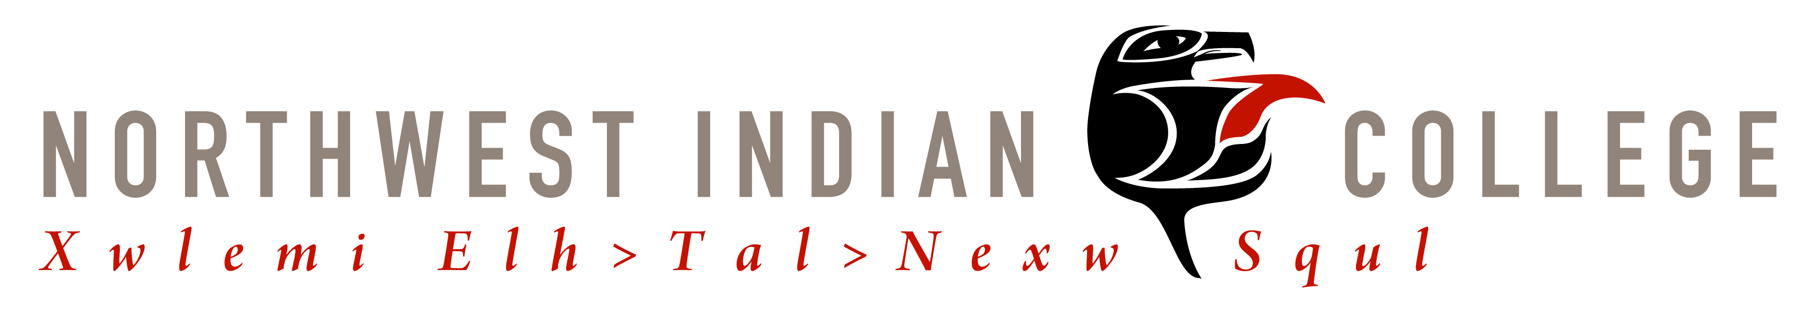
Northwest Indian College
Associate of Applied Science-Transfer Degree in Early Childhood Education
Program Outcomes

1. Promoting child development and learning: Students will be able to...
- Demonstrate knowledge and understanding of children's characteristics and needs.
- Identify, analyze, and reflect upon multiple influences on child development and learning.
- Create safe, healthy, respectful, challenging, and culturally supportive environments for learning.

2. Building family and community relationships: Students will be able to...
- Describe and reflect upon family and community characteristics within Native communities.
- Support and empower families and communities through respectful and reciprocal relationships.
- Involve Native families and communities in their children's development and learning.
- Assist families in reinforcing resilience and accessing resources.

3. Observing, documenting, and assessing: Students will be able to...
- Articulate the goals, benefits, and culturally responsible uses of assessment.
- Use observation, documentation, and other appropriate assessment tools.
- Articulate uses of assessment in partnership with families and other professionals serving Indigenous communities.

4. Teaching and learning: Students will be able to...
- Demonstrate the ability to connect with children.
- Use developmentally and culturally effective approaches.
- Demonstrate an understanding of content knowledge in early education.
- Build meaningful, culturally engaged curriculum.

5. Integrity, advocacy, warmth, joy, and attention to children (“professionalism”): Students will be able to...
- Identify with and involve selves in the early childhood field, engaging in continuous, collaborative learning.
- Act with integrity, engaging in informed advocacy for children, families, early learning programs, and themselves as early childhood educators.
- Integrate knowledgeable, reflective, and critical perspectives on early education.
- Display warmth, joy, and attention with a commitment to relationship-based care and education.

