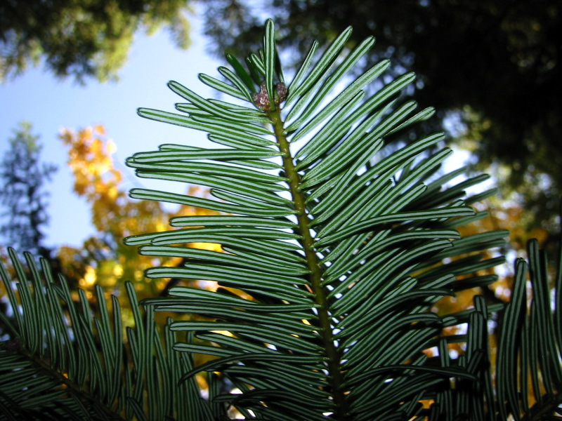
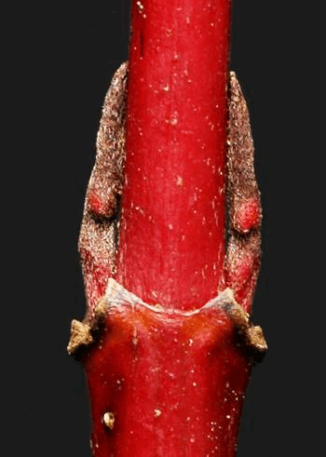
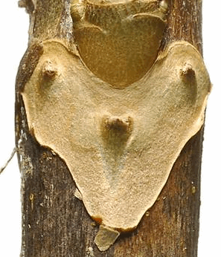
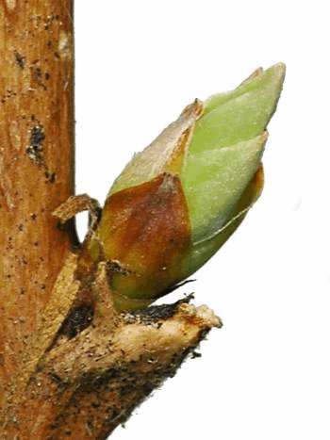
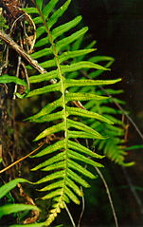

Polypodium glycyrrhiza (n.d.)
GrandFir_7591.jpg (n.d.)
Legler (2006c)
Legler (2006a)
Legler (2006b)
Course ENVS 350 Winter Plants (5 credits)
Meeting Details As indicated in the NWIC online class schedule

Instructor Information
Instructor: Brian D. Compton, Ph.D.
Office Location: Kwina Office/Classroom Complex #110 (in Building 15)
Office Hours: As posted and by appointment
Telephone/Fax: (360) 392-4321
Email: bcompton@nwic.edu
Canvas Login: https://nwic.instructure.com/login/ldap
Contents
Disclaimer 2
Philosophy Statement 2
Purpose Statement 2
Course Description 2
Prerequisites 2
Course Outcomes 2
Course Materials 2
Required Texts 2
Optional Resources and Materials 3
Online Support 3
Outline/Schedule of Topics & Assignments 4
Evaluation & Assessment—Requirements, Assignments, & Grading 6
Requirements & Assignments 6
Grading 7
Appendix: Additional Syllabus Information 9
Course Overview 9
Course Policies 9
Lummi Beliefs 10
Institutional and Program Outcomes 10
Science Writing Mentor Information 11
Rubrics 12
References 13

Disclaimer

This syllabus is tentative and subject to change by the instructor in response to class discussion, student interest, or other variables.

Philosophy Statement
The Northwest Indian College (NWIC) teaching and learning philosophy is based on the understanding that NWIC provides education that is:
- Place-based within a learning environment that intentionally focuses on cultural context and integrated cultural experiences;
- Informed by the highest expectations that students be self-motivated, disciplined, and willing learners;
- Committed to the development of the skills of our students to address issues of social justice and support the vision of their communities;
- Intergenerational with a specific focus on the development of young leadership; and
- Holistic in support of students’ understanding of who they are and their sense of place.
("Philosophy of Teaching," 2011)

Purpose Statement
This syllabus will be your guide to this academic course of instruction. It is intended to …
- Set the tone for the course.
- Communicate what, when, and how students will learn.
- Make clear to students what they need to do to be successful.
- Communicate expectations in terms of student responsibilities.
- Deter misunderstandings about course policies.
("Writing a Syllabus," n.d.)

Course Description
Study of native plants based on their winter characteristics. Focus on trees, shrubs, and vines and their environmental and cultural significance to Indigenous Peoples of the Pacific Northwest. Topics include traditional Indigenous considerations; biology, diversity, nomenclature and taxonomy; ecological significance; and collection and identification of local woody and non-woody plants.

Prerequisites

ENGL 102 English Composition II and ENVS 201 Northwest Plants.

Course Outcomes
As the result of this course students will be able to …
- Describe in biological terms the primary characteristics of pteridophytes, gymnosperms, and angiosperms, which reflect their unique attributes and relationships to each other.
- Indicate how local native plants may be identified based on characters observable in winter.
- Collect and identify local plants in accordance with established identification methods based on characters observable in winter.
- Discuss examples of traditional cultural significance of plants among Indigenous Peoples of the Pacific Northwest.
- Discuss the significance of plants as related to aspects of contemporary environmental and human affairs with emphasis on Indigenous Peoples of the Pacific Northwest.
- Construct a class project on local native plants.

Course Materials

Required Texts
Gilkey, H. M., & Packard, P. L. (2001). Winter twigs: A wintertime key to deciduous trees and shrubs of northwestern Oregon and western Washington (Rev. ed.). Corvalis, OR: Oregon State University Press. [ISBN-10: 0870715305]
Pojar, J., & MacKinnon, A. (Eds.). (2016). Plants of the Pacific Northwest Coast: Washington, Oregon, British Columbia and Alaska (Rev. ed.). Renton, WA: Lone Pine. (Original work published 1994) [ISBN-10: 1772130087, ISBN-13: 978-1772130089, originally published as Plants of Coastal British Columbia, subsequently published in 2004 as the first revised edition, and in 2016 as the second revised edition]

Optional Resources and Materials
Recommended Websites
Botany + Herbarium. (n.d.). Retrieved from Burke Museum of Natural History and Culture website: http://www.burkemuseum.org/research-and-collections/botany-and-herbarium
Jensen, E., Zahler, D., Patterson, B., & Littlefield, B. (2011, March 18). Common trees of the Pacific Northwest. Retrieved from Oregon State University website: http://oregonstate.edu/trees/index.html
Legler, B. (n.d.). Winter twig identification key. Retrieved from Burke Museum of Natural History and Culture website: http://biology.burke.washington.edu/herbarium/imagecollection.php?Page=wintertwigkey.php
Mosher, M. M. (2003). Trees of Washington (Reprint ed.). Retrieved from http://cru.cahe.wsu.edu/CEPublications/eb0440/eb0440.pdf
PLANTS database. (2018, January 2). Retrieved January 7, 2018, from United States Department of Agriculture Natural Resources Conservation Service website: https://plants.usda.gov/java/
Random access identification key. (n.d.). Retrieved from Burke Museum of Natural History and Culture website: http://biology.burke.washington.edu/herbarium/imagecollection.php
Required Fieldwork and Lab Tools and Materials
- Plastic or paper collection bags
- Field journal
- Paper for lecture notes and lab illustrations
- Pencil or pen (colored pencils are good for making enhanced illustrations, if desired)
Recommended Fieldwork and Lab Tools and Materials
- Clothing and footwear as appropriate for environmental conditions encountered during field trips (e.g., boots, rain gear, warm clothing, etc.)
- Pocketknife or secateurs (i.e., pruning shears, to collect twigs—the Felco 6 Ergonomic Compact Bypass Pruner F6 is highly recommended)
- Hand lens or loupe (a 40x 25mm magnifier with LED illumination is recommended, although various models, including all metal versions with or without LED illumination, are available)
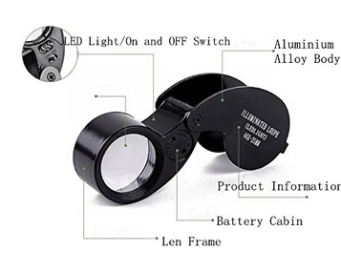

Online Support
This course is supported by a Canvas course site (see above under Instructor Information). In the event of an unscheduled college closure, check the Canvas course site for assignments and updates so that you may continue your academic progress outside of class.

Outline/Schedule of Topics & Assignments

Week 1
I. Traditional Significance of Local Native Plants as Considered in Winter
• Course Introduction
• Syllabus
• Pre-course Knowledge Survey
• Topics & Materials:
• Traditional Phenological Knowledge
• Traditional winter applications of plants
• Dendrological (anatomical and taxonomic) considerations of woody plants and associated cultural significance as sources of foods, materials, and medicines (e.g., Friedman, 1978 and Hawes, n.d.)
• Winter plants (angiosperms, gymnosperms, and pteridophytes)
• Field/Lab:
• Collection and identification of local winter plants
• Reading:
• Deep Snow Moon (Mahle & Tom, 2012)
• Assignment:
• Obtain required texts
• Due: Pre-course Knowledge Survey at 5:00 pm on Friday

Week 2
II. Native Plants in Western Washington & Their Identification as Considered in Winter
• Formative assessment exercise on course content to date
• Topics & Materials:
• Geologic and floristic contexts: Land, water, and vegetation characteristics of Washington
• Native winter plants of the Pacific Northwest
• Winter twigs
• Field/Lab:
• Collection and identification of local winter plants
• Readings:
• December 26th – treetops (Haskell, 2012)
• November 21st – twigs (Haskell, 2012)
• Assignments:
• Final Formal Paper
• Class Project
• Due: Required course texts

Week 3
• Formative assessment exercise on course content to date
• Topics & Materials:
• Native winter plants of the Pacific Northwest, continued
• Field/Lab:
• Collection and identification of local winter plants
• Reading:
• January 30th – winter plants (Haskell, 2012)
• Assignments:
• Final Formal Paper
• Class Project

Week 4
III. Native Plants as Considered in Winter & the Onset of Spring
• Formative assessment exercise on course content to date
• Topics & Materials:
• Native winter plants of the Pacific Northwest, continued
• Contemporary phenological considerations of winter plants (e.g., phenophases and climate change)
• Field/Lab:
• Collection and identification of local winter plants
• Reading:
• Little Frogs Moon (Mahle & Tom, 2012)
• Assignments:
• Final Formal Paper
• Class Project

Week 5
• Formative assessment exercise on course content to date
• Topics & Materials:
• Native winter plants of the Pacific Northwest, continued
• Field/Lab:
• Collection and identification of local winter plants
• Readings:
• June 10th – ferns (Haskell, 2012)
• Onion Moon (Mahle & Tom, 2012)
• Assignments:
• Final Formal Paper
• Class Project
• Mid-term Knowledge Survey
• Preparation for Mid-term Knowledge Survey
Week 6 (Mid-term)
• Formative assessment exercise on course content to date
• Topics & Materials:
• Native winter plants of the Pacific Northwest, continued
• Field/Lab:
• Collection and identification of local winter plants
• Assignments:
• Final Formal Paper
• Class Project
• Due: Mid-term Knowledge Survey at 5:00 pm on Friday
• Due: Mid-term Grading (and faculty-student mid-term assessment meetings)

Week 7
• Formative assessment exercise on course content to date
• Topics & Materials:
• Native winter plants of the Pacific Northwest, continued
• Field/Lab:
• Collection and identification of local winter plants
• Assignments:
• Final Formal Paper
• Class Project

Week 8
IV. Environmental Significance of Local Native Plants as Considered in Winter
• Formative assessment exercise on course content to date
• Topics & Materials:
• Native winter plants of the Pacific Northwest, continued
• Environmental considerations of winter plants, e.g., in riparian zone restoration
• Field/Lab:
• Collection and identification of local winter plants
• Assignments:
• Final Formal Paper
• Class Project
• Due: Draft Formal Paper at 5:00 pm on Friday

Week 9
• Formative assessment exercise on course content to date
• Topics & Materials:
• Native winter plants of the Pacific Northwest, continued
• Field/Lab:
• Collection and identification of local winter plants
• Reading:
• Little Fawns Moon (Mahle & Tom, 2012)
• Assignments:
• Final Formal Paper
• Class Project
• Due: Final Formal Paper at 5:00 pm on Friday

Week 10
• Topics & Materials:
• Development of exhibit on local winter plants
• Field/Lab:
• Development of exhibit on local winter plants
• Class Discussion of Final Student Papers

Week 11
• Course Conclusion
• Assignments:
• Class project
• Final Knowledge Survey
• Self-assessment of Learning
• Due: Class Project Part A: Checklist of Winter Plants
• Due: Class Project Part B: Exhibit of Winter Plants
• Due: Final Knowledge Survey at 12:00 pm on the last day of the quarter
• Due: Self-assessment of Learning at 12:00 pm on the last day of the quarter

Evaluation & Assessment—Requirements, Assignments, & Grading
In this course, I will use the term evaluation (which may also be referred to as summative assessment) to refer to the process of reviewing students' course requirements and assignments for the purpose of determining their value as related to a standard (such as one or more course rubrics) and to determine the grade students have earned as indicated below. I will also engage in formative assessment for each student with the goal of providing ongoing feedback that I and students may use to improve our teaching and learning ("Whys and Hows," n.d.). In addition, I may be requested to review the overall results of this course for the purposes of Bachelor of Science in Native Environmental Science program assessment. This latter assessment has no impact on the grade you will earn in this course but has the goal of improving that program. Finally, self-assessment of student learning is included in this course, which may include student engagement in self-reflection and metacognition (i.e., thinking about one's thinking) to determine not only what students have learned but how they have learned it with a view to improving their learning strategies in the future (Gooblar, 2015, cf. Rolheiser & Ross, 2013). A potential additional goal of self-assessment is to help students be better equipped to provide feedback on this course and my efforts.

Requirements & Assignments
Note: This course is based on a total of 100 possible points, including elements as indicated below. In addition, various non-graded formative assessment exercises may be included as discussed above.
- Attendance and Participation (0 points or 0% of final grade)
(Attendance will be recorded and reported to Enrollment Services for financial aid purposes but will not contribute points for grading purposes. That being said, attendance and participation are essential to the successful completion of this course.)
- Pre-course Knowledge Survey (5 points or 5% of final grade)
(This is a brief written assignment to address the approved course outcomes. Complete assignments that address each course outcome will receive all the possible points.)
- Mid-term Knowledge Survey (15 points or 15% of final grade)
(This will involve student work regarding learning with a focus on course outcomes up to the mid-term.)
- Final Knowledge Survey (20 points or 20% of final grade)
(This will involve student work regarding learning with a focus on course outcomes up to the end of the term.)
- Final Formal Paper (25 points or 25% of final grade)
(For this course, this assignment may take various forms. For example, students may choose to research, write on, and present on various mycological topics, or they may choose to address a topic using a monographic approach, to be further defined in class. Student work should seek to address one or more course outcomes in this assignment.)
(Formal written research reports consist of seven (7) pages, not counting the separate title page, abstract page, and references section. They should include a minimum of four (4) references. These are to be produced in accordance with APA [American Psychological Association] Style guidelines, submitted in electronic form, and to address editorial review and feedback to be eligible for full credit. They will be evaluated according to the corresponding rubric presented in the appendix to this syllabus. Complete assignments will receive all the possible points. Note: An assignment template is available upon request from the instructor.)
- Class Project Part A—Checklist of Local Winter Plants (15 points or 15% of final grade)
(This will consist of a group effort regarding a final list of all local native woody species observed, collected, and identified during the term.)
- Class Project Part B—Exhibit of Local Winter Plants (15 points or 15% of final grade)
(This will consist of a group effort to construct an exhibit of local winter plants for presentation at the end of the term.)
- Self-assessment of Learning (5 points or 5% of final grade)
(This should consist of a written report on 1) what you consider to be important knowledge and skills that you gained from this course, 2) what you regard as positive efforts on your part that have contributed to your success in this course, 3) limiters or barriers to your attainment of course learning outcomes, and 4) details regarding the grade you believe you earned in this course. This assignment does not need to comply with APA Style guidelines and is not subject to editorial review and feedback.)

Grading
Note that students must complete course requirements as described in this syllabus to be eligible for receiving a grade for this course. Northwest Indian College uses the following symbols for grading courses:
      - A: The student has met or exceeded the highest level of the course requirements.
      - B: The student has met the course requirements above the satisfactory level.
      - C: The student has met the course requirements at the satisfactory level.
      - D: The student has met the course requirements at the minimum level. However, the student has not met all of the course requirements at the satisfactory level.
      - F: The student has not met the course requirements at the minimum level.
In this course, the following points and percentages will be associated with letter grades:
Grade Points Earned Percentage
A 95-100 95-100%
A- 90-94 90-94%
B+ 86-89 86-89%
B 85 85%
B- 80-84 80-84%
C+ 76-79 76-79%
C 75 75%
C- 70-74 70-74%
D+ 66-69 66-69%
D 65 65%
D- 60-64 60-64%
F 0-59 0-59%
Please also note the following important details regarding grading.
- Incomplete Agreement Policy Statement: If a student has been making consistent progress and has regular attendance, but some essential requirement of the course has not been completed because of unforeseen circumstances the student has the option to request to enter into an incomplete agreement. The deadline to request an incomplete agreement is the last day of the quarter. It is the instructor’s discretion whether to accept the student’s request. When the instructor submits an incomplete agreement for a student, included should be:
  - The grade earned by the student on the date that the incomplete agreement is submitted,
  - A detailed list of remaining work to be completed, and
  - A deadline for the completion of that work. (The deadline is not to extend longer than two consecutive quarters.)
- Grade Change Policy: Grade and designation of Incomplete recorded by the registrar at the end of a quarter will be considered final and not be changed except in the following cases:
  - When a letter grade is submitted to replace the incomplete, by the instructor of record or, if the instructor of record is no longer employed by NWIC, by the Dean of Academics.
  - When a grade resulting from an error, such as a computation error, is corrected by the instructor of record; the request for change to correct these errors may only be made by the instructor of record, before the beginning of blue-slip week (second week of the quarter) or the following quarter.
  - When an error committed in the administrative recording process is corrected by the registrar’s office.
  - When a student’s grade appeal has been adjudicated, as outlined in the grievance procedure in the Student Handbook.
IMPORTANT NOTE: Details regarding the Incomplete Agreement and Grade Change policies appear in the 2017-2019 Northwest Indian College Catalog. Please also note that your instructor for this course requires completion before the end of the quarter of a written Incomplete Agreement Request Form, which is available upon request, and documentation of the compelling reason for agreeing to pursue an incomplete agreement, such as evidence of medical emergency, etc.
- Other Considerations
  - Completion of an assignment does not ensure receipt of full credit for that assignment. I will evaluate your work for its promptness, appropriateness, completeness, quality, and relationship to one or more evaluation rubrics. All work must be completed as indicated elsewhere in this syllabus or—only with prior permission of the instructor and because of unavoidable circumstances—by noon of the last day of the quarter unless an Incomplete Agreement is requested and completed as indicated above.
  - Grade qualifiers (- or +) may accompany your final grade depending upon various factors to be determined by your instructor with respect to the promptness and quality of your efforts.

Appendix: Additional Syllabus Information

Course Overview
Winter Plants: Native woody plant species in western Washington include both gymnosperm species (typically evergreens, including 8 evergreen trees, 1 evergreen shrub, and 1 deciduous tree) and angiosperm species (typically deciduous, including 39 deciduous species, i.e., 13 trees, 24 shrubs, and 2 vines, as well as 1 evergreen tree and 13 evergreen shrubs, noting that distinctions between a small tree and a large shrub may vary by author). Both evergreen and deciduous woody plants play significant ecological roles in the local environment as well as significant cultural roles amongst local Indigenous peoples. Primary focus in this course will be on local native woody deciduous plant species, which share the common attribute of shedding (through abscission) of some or all of their leaves in the winter when they become dormant. Both dormant state morphological (external) characteristics as well as anatomical (internal) characteristics may be used to identify these plants to species. Attention will also be given to the identification of local gymnosperms, evergreen pteridophytes (ferns and their relatives), and other botanical organisms that may be observed in winter. This course will involve the collection, identification, and study of local native vascular plants.
Seasonal Considerations: Of the trees and shrubs in our region, several are evergreen gymnosperms, and a few are evergreen angiosperms. There also are several pteridophytes that have evergreen vegetative structures, which may be used to identify them in the winter. At other times of the year, when local deciduous angiosperm species have leaves, identification efforts include aspects of foliage, flowers, and fruits. Gymnosperm species may be identified throughout the year based primarily on vegetative and reproductive characteristics. ENVS 201 Northwest Plants may be offered in other quarters for students interested in learning more about local native plants (including woody plants as well as herbaceous perennials, aquatics, ferns, grasses, sedges, and rushes), and their identification and cultural significance throughout other seasons of the year.
The United Nations Declaration on the Rights of Indigenous Peoples (UNDRIP, in part): The statement that "Indigenous peoples have the right to their traditional medicines and to maintain their health practices, including the conservation of their vital medicinal plants, animals and minerals" appears in Article 24, Paragraph 1 of the UNDRIP. In addition, "Indigenous peoples have the right to maintain and strengthen their distinctive spiritual relationship with their traditionally owned or otherwise occupied and used lands, territories, waters and coastal seas and other resources and to uphold their responsibilities to future generations in this regard" appears in Article 25 of the UNDRIP. "Indigenous peoples have the right to maintain, control, protect and develop their cultural heritage, traditional knowledge and traditional cultural expressions, as well as the manifestations of their sciences, technologies and cultures, including human and genetic resources, seeds, medicines, knowledge of the properties of fauna and flora, oral traditions, literatures, designs, sports and traditional games and visual and performing arts. They also have the right to maintain, control, protect and develop their intellectual property over such cultural heritage, traditional knowledge, and traditional cultural expressions" appears in Article 31, Paragraph 1 in the UNDRIP (United Nations, n.d.).
Fungi and Coast Salish Considerations at Northwest Indian College: You are encouraged to consider our work together in this course in light of the Lummi beliefs, which are included in the 2017-2019 Northwest Indian College Catalog:
- sela-lexw: Our strength comes from the old people. From them we receive our teachings and knowledge and the advice we need for our daily lives.
- schtengexwen: We are responsible to protect our territory. This means that we take care of our land and the water and everything that is on and in it.
- xwlemi-chosen: Our culture is our language. We should strengthen and maintain our language.
- leng-e-sot: We take care of ourselves, watch out for ourselves and love and take care of one another.
- xaalh: Life balance/sacred (an additional belief not included in the 2017-2019 Northwest Indian College Catalog.)

Course Policies
- Student Rights & Responsibilities: These will be observed as described in the 2017-2019 Northwest Indian College Catalog and in accordance with Northwest Indian College policies.
- Attendance & Participation: Regular attendance and participation are essential to your success in this course. It is your responsibility to attend class meetings regularly and on time. If you may arrive to class late, please be mindful that the course work has already begun and that class interruptions may negatively impact your classmates’ and the instructor’s efforts regarding teaching and learning. Necessary absences should be reported to your instructor and multiple unexcused absences may result in grade reductions that could prevent you from passing this course.
VERY IMPORTANT NOTE: Students must attend at least one (1) class for their financial aid to be disbursed. If attendance is not logged for a student for two (2) weeks, a return of funds must be calculated. NWIC has 45 days from the last date of attendance to return the Title IV funds. Financial Aid will check attendance every Thursday.
- Assignments & Due Dates: All assignments are to be submitted as indicated by the instructor and in supporting course materials. You must complete your work as indicated in this syllabus and in class or you will not receive credit for that work. Unless otherwise instructed, you are required to submit your work in electronic format (i.e., Microsoft Word) via Email to Brian Compton at bcompton@nwic.edu. I will not accept late assignments without prior approval.
- Evaluation & Grades: The grades that I will report on the class grade roster at the end of the quarter may be determined through evaluation as detailed in this syllabus and described in class and course materials.
- Electronic Devices (e.g., cell phones and laptop computers): Please be sure to reserve cell phone and laptop use for outside of class unless they are being used with the instructor's approval and in direct support of your on-task course work.
- Email: I will use your NWIC Email address to communicate with you in this course, so you must access it to receive any messages that I send to you via that address. Please use your NWIC Email address to communicate with me and notify the Information Services Department immediately if you experience any difficulties with your student account to help ensure effective communication with me.

Lummi Beliefs
The educational philosophy of Northwest Indian College is based upon the acknowledgement that Tribal values and beliefs are the foundation of education and must include a study of Native American culture, language, and history within the Tribal community. The College's extended campus sites participate by identifying the values and believes that underlie the educational approach appropriate to their communities' needs.
- sela-lex^{w}—Our strength comes from the old people. From them we received our teachings and knowledge and the advice we need for our daily lives.
- schtengex^{w}en—We are responsible to protect our territory. This means that we take care of our land and the water and everything that is on it and in it.
- xwlemi-chosen—Our culture is our language. We should strengthen and maintain our language.
- leng-e-sot—We take care of ourselves, watch out for ourselves and love and take care of each other.
- xaalth—Balance.

Institutional and Program Outcomes

NWIC Institutional Outcomes
The institutional outcomes that this course seeks to support are:
- Native Leadership—To Acquire a Quality Education
  - Effectively communicate in diverse situations, from receiving to expressing information, both verbally and non-verbally
  - Use analytical and critical thinking skills to draw and interpret conclusions from multiple perspectives including Indigenous theory and methods
- Way of Life—To Give Back
  - Demonstrate knowledge of what it means to be a people
  - Practice community building through service learning
- Inherent Rights—To Apply Indigenous Knowledge
  - Exhibit a sense of place
  - Recognize Tribal rights as they relate to human rights
- Community Minded—To Utilize Education Through Work
  - Meet the technological challenges of a modern world
  - Work cooperatively toward a common goal

Bachelor of Science in Native Environmental Science Program Outcomes
The program outcomes that this course seeks to support are:
- Sense of Place
  - Value the interrelationships between people and the environment.
  - Ground and apply concepts and methodologies to place.
- Relationality
  - Demonstrate self-location within inquiry-based research.
  - Value relationality in the practice of Native Environmental Science.
  - Evaluate and interpret environmental laws, policies, and acquired rights, and advocate for inherent rights.
- Inquiry
  - Use Indigenous theories and methods to conduct inquiry-based research and evaluation that respond to the needs of Indigenous communities and serve to promote Indigenous self-determination.
  - Evaluate and use appropriate technologies for inquiry-based research in support of restoration and revitalization of the environment.
  - Evaluate and apply quantitative, qualitative, and mixed methodologies and concepts that include the synthesis of complex information.
- Communication
  - Communicate using oral, written, and graphical (visual) methods to support Indigenous self-determination.
  - Communicate effectively to multiple audiences, including Indigenous communities, policy makers, scientific communities, and the general public.

Science Writing Mentor Information
Please note that this course involves several writing assignments that are to be developed through collaboration with the Science Writing Mentor at Northwest Indian College, whose contact and availability information is presented below. Please consult with her for further details regarding her availability and turn-around time for reviewing and providing editorial feedback on writing assignments.
Writing Mentor: Lynda Jensen, M.A.
Office Location: When not in class, Ms. Jensen is most reliably found in her office in the Testing Center (in Building 17) or in the Science Lounge (room NE106 in Building 16).
Mentor Hours: Please check with Ms. Jensen.
Telephone: (360) 392-4303
Email: ljensen@nwic.edu

Rubrics
Rubric for Formal Paper
Evaluation Attribute | Possible Points
Complete & Concise: All components of the assignment are included, and writing is economical and direct. | 5
Correctness: All required components are correctly developed and presented. All aspects of grammar, spelling, punctuation and word choice are present. | 5
Coherence (& Control): Content is presented logically and in a unified manner with good flow, paragraph construction, sentence content, etc. | 5
Clarity: Writing is clear and unconfused and relates directly to the stated assignment objective(s). | 5
Content & Course Outcomes: Writing shows evidence of full and complete comprehension of subject matter, content communicated is substantial and relevant, and one or more course outcomes are appropriately addressed. | 5
All Attributes | 25 total points possible
Rubric for Checklist of Local Winter Plants
Evaluation Attribute | Possible Points
Complete & Concise: All components of botanical nomenclature and classification are present and concisely presented. | 3
Correctness: All required components are correctly developed and presented. All aspects of spelling, formatting, and other mycological writing conventions are present. | 3
Coherence (& Control): Content is presented logically and in a unified manner, etc. | 3
Clarity: Writing is clear and unconfused and relates directly to the stated assignment objective(s). | 3
Content & Course Outcomes: Writing shows evidence of full and complete comprehension of subject matter, content communicated is substantial and relevant, and one or more course outcomes are appropriately addressed. | 3
All Attributes | 15 total points possible
Rubric for Exhibit of Local Winter Plants
Evaluation Attribute | Possible Points
Complete & Concise: All components of botanical nomenclature and classification are present and concisely presented. | 3
Correctness: All required components are correctly developed and presented. All aspects of spelling, formatting, and other mycological writing conventions are present. | 3
Coherence (& Control): Content is presented logically and in a unified manner, etc. | 3
Clarity: Writing is clear and unconfused and relates directly to the stated assignment objective(s). | 3
Content & Course Outcomes: Writing shows evidence of full and complete comprehension of subject matter, content communicated is substantial and relevant, and one or more course outcomes are appropriately addressed. | 3
All Attributes | 15 total points possible

References
Friedman, J. (1978). Wood identification by microscopic examination: A guide for the archaeologist on the Northwest coast of North America. Victoria, Canada: British Columbia Provincial Museum.
Gooblar, D. (2015, December 2). How, and why, you should have students assess themselves. Retrieved from https://chroniclevitae.com/news/1214-how-and-why-you-should-have-students-assess-themselves
GrandFir_7591.jpg [Photograph]. (n.d.). Retrieved from https://upload.wikimedia.org/wikipedia/commons/b/b3/GrandFir_7591.jpg
Haskell, D. G. (2012). January 30th – winter plants. In The forest unseen: A year's watch in nature (pp. 21-24). New York, NY: Viking.
Haskell, D. G. (2012). November 21st – twigs. In The forest unseen: A year's watch in nature (pp. 213-221). New York, NY: Viking.
Haskell, D. G. (2012). The forest unseen: A year's watch in nature. New York, NY: Viking.
Hawes, K. L. (n.d.). Microscopic identification by cellular analysis: A comparison of artifact plant materials from wet-sites of the northwest coast of North America. Retrieved from http://newswarp.info/wp-content/uploads/2010/03/Wet-Site-Wood-Fiber-and-Charcoal-Cellular-ID-Hawes1.pdf
Legler, B. (2006a). Image ID: 16926 [Photograph]. Retrieved from http://biology.burke.washington.edu/herbarium/imagecollection.php?ID=4004
Legler, B. (2006b). Image ID: 17066 [Photograph]. Retrieved from http://biology.burke.washington.edu/herbarium/imagecollection/imagelarge.php?ImageNumber=17066&TaxonID=1366&SourcePage=taxon&
Legler, B. (2006c). Image ID: 17079 [Photograph]. Retrieved from http://biology.burke.washington.edu/herbarium/imagecollection/imagelarge.php?ImageNumber=17079&TaxonID=2119&SourcePage=taxon&
Mahle, G., & Tom, L. (2012). Where words touch the earth: Tribal students produce a climate change video on the Coast Salish Moons. In Z. Grossman & A. Parker (Eds.), Asserting native resilience: Pacific rim indigenous nations face the climate crisis (pp. 40-43). Corvalis, OR: Oregon State University Press.
Philosophy of teaching and learning. (2011, September 8). Retrieved from Northwest Indian College website: http://blogs.nwic.edu/teachinglearning/2011/09/08/teaching-and-learning-philosophy/
Polypodium glycyrrhiza - Eaton. [Photograph]. (n.d.). Retrieved from https://www.pfaf.org/USER/Plant.aspx?LatinName=Polypodium+glycyrrhiza
Rolheiser, C., & Ross, J. A. (2013, May 9). Student self-evaluation: What research says and what practice shows. Retrieved from Mainstee County Schools website: http://moodle.manistee.org/pluginfile.php/59439/course/section/16807/STUDENT%20SELF-EVALUATION%20WHAT%20RESEARCH%20SAYS%20AND%20WHAT%20PRACTICE%20SHOWS.pdf
Whys and hows of assessment. (n.d.). Retrieved from Carnegie Mellon University website: https://www.cmu.edu/teaching/assessment/basics/formative-summative.html
Writing a syllabus. (n.d.). Retrieved from Cornell University Center for Teaching Excellence website: https://www.cte.cornell.edu/teaching-ideas/designing-your-course/writing-a-syllabus.html

