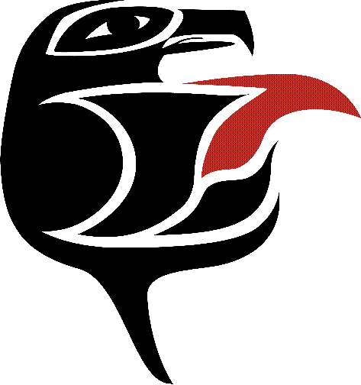

Course Outcomes Form

Northwest Indian College

Follow the Instructions for Completing the Course Outcomes Form, which is available on the NWIC Assessment Website at http://www.nwic.edu/assessment

Please submit this form electronically to the Chair of the Curriculum Committee
It is important to keep the following principles in mind when completing this form:
- Regardless of the mode of learning (i.e., face-to-face, Independent learning, ITV, online, etc.) or the location of a course, only one course outcomes form is to be created for each course.
- Regardless of the mode of learning or the location of a course, the NWIC outcomes and the Course outcomes must be the same for each course.
- The Instructional activities and the Assessment/evaluation strategies may differ depending on the mode of learning. Please indicate the Instructional activities and the Assessment/evaluation strategies that are different from the face-to-face class (e.g., “IL: Essay”).

Most recent date this form was updated or edited | 10/23/17
Course Number  (e.g., ENGL 101) | ENGL 305
Course Name (e.g., English Composition I) | Technical Writing for Tribal Leaders
List the names of all instructor(s) and others who participated in creating and approved these course outcomes (consult with at least one other person) | Michelle Gladstone, Lynda Jensen, Laural Ballew
List the main textbooks, readings or other resources used in this course | Robin Wall Kimmerer, Braiding Sweetgrass  Online Writing Lab (OWL), Purdue University  APA Style Blog

A. NWIC Institutional Outcomes: Select the most important NWIC institutional outcomes that are assessed in this course (at least one NWIC outcome must be chosen and up to all eight outcomes).

NWIC institutional outcome # (e.g., #3 - “demonstrate knowledge of what it means to be a people”) | Instructional Activities: How will students master this outcome? (e.g., solving problems, group activity) | Assessment/Evaluation Strategies: How will you measure this outcome? (e.g., student presentations, essays)
Effectively communicate in diverse situations, from receiving to expressing information, both verbally and non-verbally. | Timely submission of homework is critical for grade success.  Writing is submitted and reviewed in a group setting; every student receives individualized feedback. | Well-composed assignments including an annotated bibliography, a literature review, an IRB application, a capstone proposal, and an individual editing and proofreading checklist.
Use analytical and critical thinking skills to draw and interpret conclusions from multiple perspectives including Indigenous theory and methods. | Group feedback sessions require students to be present, attentive, and supportive of their peers' efforts and improvements. | Attendance and participation in group review sessions are mandatory.
Work cooperatively toward a common goal. | The class opens with a discussion of leng-e-sot. The group work requires looking out for one another and helping one another succeed. | Attendance and participation in group review sessions are mandatory.

B. Course outcomes: In order of priority, list the central learning outcomes for this course that are assessed (a maximum of 10).

Other course outcomes: Complete the sentence –  As a result of this course, students will be able to… | Instructional Activities: How will students master this outcome? (e.g., solving problems, group activity) | Assessment / Evaluation Strategies: How will you measure this outcome? (e.g., student presentations, essays)
Perform efficient research. | We perform research together; students write an annotated bibliography and share it with the class to receive feedback; from this, they create their literature review. | A literature review is due at the end of the quarter.
Refine their personal writing style and methods, eventually creating and utilizing a tailored proof-reading checklist. | Reflection is a part of the group work each week: students discuss how their work is coming along and suggestions for strategic improvements are offered (by instructor and peers). | An individualized checklist is required as a final assignment.
Refine their ability to assess academic tasks and plan for success. | Efficacy questionnaires book end the class. Students are asked to start with a plan for success and end with an evaluation of what worked and what could be improved to enhance their success. | Self-efficacy questionnaire and success essay during week one; reflection essay evaluating their approaches in week 11.
Demonstrate advanced academic writing and editing skills. | We recognize and accept that all academic writing requires editing; we explore the idea that writing and editing helps us refine our thinking; all writing is reviewed and improved. An iterative thinking and writing process is the focus of the course work. | Every assignment (except the success essay in week 1) is submitted for review, and returned with suggestions for improvement. The improved documents are submitted for a grade.

C. List the NWIC outcomes and course outcomes from above on your syllabus.

D. Assess the NWIC outcomes and course outcomes, which are listed above, in your classes.

