LEED Certification Coming Full Circle in Indian Country

Maggie Picard

Thesis Project
Spring 2010
Northwest Indian College

Abstract

From years gone by, Native Americans have worked in harmony with the natural habitat in which they lived. Homes and community buildings were made from nature, not from man-created materials. Every resource was utilized to its highest degree, wasting nothing and keeping in mind that careful attention to the elements in design, building and structure were critical to the purpose of the structure.
This paper will show many similarities between the Leadership in Energy and Environmental Design (LEED) Certification process and the past building practices of Native Americans. Included is a brief examination of the building practices of three tribes, a look at some examples of current day Tribal LEED policies and an example of a case study which will emphasize one tribe’s building of a college science lab hoping to gain LEED certification.
The Northwest Indian College Natural Resource Lab is a project with many “green” features. It is a 4,750 square foot building that incorporates critical cultural design aspects with energy efficiency and plans for follow through ensuring that any negative impact upon Mother Nature will be minimal, thus ensuring use for generations to come in a positive way.
The Northwest Indian College through collaboration with Lummi Nation has shown through as a commitment to sustainability in this project as well as other buildings located on the College campus. Energy efficiency, waste management, solar energy generation and purposeful placement of the building are highlights of this project.
It has been a wonderful and exciting experience researching, writing and developing this report for my thesis project. Gaining insight into true “green” building is good for the Tribe, good for Education and a very good example of a Tribal facility process that may help others to follow.
1. Introduction 4
2. Methodology 5
3. Background 7
3a. Traditional Building Practices in Indian Country 7
3b. History of LEED 12
3c. History of LEED in Indian Country 15
4. Case Study: NWIC Natural Resource Lab Building 17
4a. Overview 17
4b. The Natural Resource Lab Building- General 18
4c. Cultural Representation of the Natural Resource Lab 18
4d. Natural Ventilation System 19
4e. Radiant Floor Heating 20
4f. Natural Light and Views 21
4g. Recycled Materials-Reduce and Reuse 21
4h. Low VOC Materials 22
4i. Renewable Energy- Green Power and Solar Panels 22
4j. Reclaimed Water 23
5. Discussion and Conclusions 24
6. Acknowledgements 26
7. Bibliography 26
8. Appendix 29

1. Introduction

Buildings have great impact on the Earth, the environment, the habitat where they are located, and on natural resources. Sustainable building is the creation of a structure where each aspect of the design, construction, renovation, and operation pays attention to use and reuse of materials in a resourceful and environmentally friendly way.
Leadership in Energy and Environmental Design (LEED) is a certification process which recognizes sustainable designs and buildings. Sustainable building has occurred in Native American history for centuries. Through sustainable building and LEED certification an alliance of creativity and resourcefulness is being established with a goal of preserving Mother Earth.
Sustainable building is receiving attention at a global level. The practices of constructing a building are changing in ways that help maintain the ecology of the surrounding site and minimize damaging effects on nature. Buildings in the 19th century were used mainly as homes and built onsite. Today, there are more residential, commercial, business, and industrial buildings that are fabricated and taken to the site to be pieced together rather than ‘built’ onsite.
Building industry impact on the environment must slow down if natural ecosystems are to maintain their stability. LEED builders utilize sustainable building practices to reduce negative effects on the Earth by means of high-performance construction, design, and operation practices, and in doing so they gain reduced operating costs, as well as increasing the building’s efficiency, worker productivity, lessening possible dangers due to poor construction and to quality of air.
In the past, people of most Native nations considered themselves caretakers of the land. Sustainable building came naturally to Native people who used bio-degradable materials that had no negative impact on Mother Earth. Over time they lost the traditional practices of their ancestors. Sustainable building now has to be relearned through technical programs.
Using ideas of sustainable building, LEED, and Native American influences and contributions to this paper will first explore the history and traditions of Native building practices. Next we will discuss the history of LEED and the history of LEED in Indian country. Finally, the paper will conclude with an examination and case study of the Natural Resource Lab building at Northwest Indian College and its impact on Mother Earth.

2. Methodology
There appears to be similarities between past practices in Native building and the ideals in LEED certification. Obviously, plankhouses, longhouses, and tipis had to be built with natural resources and in ways that were easily constructed and deconstructed because most tribes were at least somewhat nomadic. Because of the work put into each component, most materials were reused as often as possible. Energy efficiency and attention to engineering and designs were critical elements in their construction. Natural resources long ago were animal parts, greenery, bark and trees were common materials that were also used in other projects so that they could be repurposed and/or never wasted. This paper looks to see if these concepts of Native construction are an important part of LEED certification.
Research for this paper included a literature review and interviews with professionals who are involved in the profiled construction at NWIC. A case study highlighting the sustainable and “green” features of the Natural Resource Laboratory (NRL) building at NWIC is used to illustrate the information found in the research.
The literature review helped shape the author’s interest in Native American building practices. Many examples of the historical building styles of Native Americans carried through thematically to the design of the NRL at NWIC.
There were many on-site observations of the NRL building with the direction of Jay Conway, Project Manager of Construction. Information and materials contained in this paper are from Mr. Conway, the NWIC library, Ebscohost and Proquest research databases. LEED concepts that portray the traditional building practices of Native Americans are correlated through discussion with the design concepts of the NRL building.
The primary-literature review was an important aspect of the research, as it helped me clarify my interest in Native American building practices, that is, to see if what we (Native Americans) had learned in the past will come full circle in helping the land become healthy once again. Comparison to other LEED projects in Indian Country are included to illustrate how far that circle has closed.

3. Background

3a. Traditional Building Practices in Indian Country
“A tangible expression of a way of life,” is how Bernard Rudovsky, an architectural historian summarizes Native American building styles of the 1800’s. (Nabokov, Easton, p.12). According to Native American Architecture, there were over three hundred different tribal entities living within the North American continent when Christopher Columbus first touched shore. As with other Native American traditions, building techniques were passed on from generation to generation through oral teachings and storytelling. Native people did not write protocols and practices down.
Keeping planning and managing simple was how Native people built buildings. Planning included group deliberation before the execution in order to make sure there were enough materials to employ the builders. Native communities made all of their buildings from raw, bio-degradable materials, never harming Mother Earth. Managing the building was the responsibility of all who dwelled within the home.
As Rudovsky points out, buildings were part of the expression of Native people’s lives which were dependent on connection to Mother Earth. Therefore most structures were created to be functional, to aid survival through the seasons as well as promote harmony with Earth. Although there were a few structures built for status or ceremony or other non-essential purposes.
Three Native American Nations and their traditional buildings will be reviewed and discussed in this paper: Coast Salish plankhouses, Nez Perce longhouses and tipis, and the Plains Cree tipis. The author has closely interacted with the three tribes included in this study. The buildings studied were built as homes and adapted to the region of construction by factors such as weather, harvestable materials, need for mobility of the people to find food, and most important landscape. The book, Native American Architecture, states, ‘by our houses you will know us.’ Each of these unique buildings will show this statement to be true and will show each Native group as people of the land.
The plankhouse was an architectural staple for the Coast Salish Native Americans of the Pacific Northwest, created using the cedar tree. This home design was durable and resourceful, and it was very much part of their livelihood. A plankhouse was rectangular (approx. 40 feet by 20 feet) with cladding (siding) and roofing which were strips of cedar, or ‘planks’ made by splitting a tree lengthwise into the desired width. (See diagram)
This Native American Architecture, the plankhouse is described as:

In western British Columbia, Canada, the oldest found plankhouse village is located in Kitselas Canyon at the Paul Mason site. The plankhouse village site is estimated to be 3000 years old. Simon Fraser wrote in his 1800 journal about Coast Salish homes upon what is now called the Fraser River. Fraser wrote, ‘an excellent house 46’x32’ and constructed like American frame houses; the planks are three to 4 inches thick, each plank overlapping the adjoining one a couple of inches; the posts, which are very strong and crudely carved received cross beams; the walls are 11 feet high and covered with a slanting roof. On the opposite side of the river there is a considerable village with houses similar to the one on the side.’

Plankhouses contained significant design simplicities. They were practical as they were created using sustainably harvested materials. Maintenance practices included reuse of materials whenever possible. They were designed according to weather patterns as studied from previous seasons. The cedar tree was an excellent choice of wood because its properties met the needs of the plankhouse, i.e., straight grain, few knots, and weather resistance. Also harvested from the cedar tree were cedar ropes which helped secure the beams and planks to the upright position. When the Native Americans of the coast were ready to relocate the planks were easily deconstructed and hauled to the next location.
In the varied landscape, i.e. plateau, high valleys, lava beds, mountain ranges, and grasslands, of what is now Eastern Washington State and Idaho, the Nez Perce people lived in homes called longhouses and tipis. Longhouses were also called ‘long lodges’ because they were longer than wider. Longhouses were utilized for extended family visits, ceremonies, funerals, and gathering of people.
Lodgepole pine, a versatile wood, was the material of choice because it held the structure upright for long periods of time through different weather patterns. Lodgepole pine is tall, thin and pliable. Because it is strong these support poles can be kept for many years and reused. The framework resembled an inverted-V; there are no upright interior support poles in the structure. The longhouse structure was useful through the winter season as it promoted heat retention. (See diagram) During harsh Prairie weather, strong winds moved from the base of the tipi up toward the top and over keeping the harsh cold weather outside. Conversely, in the summer it was easy to pull up the sides to allow free flowing wind and fresh air.
The Nez Perce people also utilized the inverted-V conical tipi for individual families to dwell in. Tipis are resourceful and easily constructed dwellings as they are adaptable to the different landscapes of the Nez Perce lands. Made from several wood poles covered with animal hides, the tipi is easily transported to different areas by horses, or dogs. Tipis are a significant architectural structure utilized by the Nez Perce still today.
The Cree people of the Plains also lived in tipis. The structure was also made from lodge-pole pine or straight trees and was covered with animal hides. Differing from the Nez Perce, the Cree tipi was a four-pole framing system. Typically, the builders would tilt the rear-side poles making the tipi steeper so it could withhold the prairie’s winds, and the doorway would face the east to take advantage of light and heat of the sunrise.
The architectural design of the tipi is estimated to have existed for at least five thousand years ago (Nabokov, Easton, 150). The building practices of a tipi are created for the local weathering system. The supplies needed to construct a tipi are wood poles, stakes, pins, rope, and hide covering. Tipis are durable as they are quickly assembled and easily dismantled in extreme weather and temperatures. (See diagram)

3b. History of LEED
Leadership in Energy and Environmental Design (LEED) was created by the United States Green Building Council (USGBC), a national nonprofit organization. USGBC’s mission for LEED is to transform the way buildings and communities are designed, built, and operated, thus enabling a healthy, environmentally and socially responsible, and prosperous environment that improves the quality of life.
In 1993, the United States Green Building Council was formed. The organization noticed ‘the sustainable building industry needed a system to define and measure “green buildings.”(Green Building Design and Construction, p. xi)
A committee was formed, dedicated to learning and researching sustainable building in order to make it better. The committee consisted of: architects, real estate agents, environmentalists, lawyers, building owners, and industry representatives as they provided ‘richness and depth to the process and the ultimate product.’ (Green Building Design and Construction, xi)
The first LEED pilot project program, LEED version 1.0, was presented at the USGBC Membership Summit in August of 1998. Revised and refined since then, LEED has a set of standards for certifying the design and construction of buildings as environmentally conscious and sustainable. The standards are separated into 7 main areas for building which are:
- Sustainable Sites (SS)
- Water Efficiency (WE)
- Energy and Atmosphere (EA)
- Materials and Resources (MR)
- Indoor Environmental Quality (IEQ)
- Innovation in Design (ID)
- Regional Priority (RP)
Seven different kinds of building projects can be certified which are:
- New Construction (LEED-NC)
- Commercial Interiors (LEED-CI)
- Existing Buildings (LEED-EB)
- Schools (LEED-S)
- Core and Shell (LEED-CS)
- Neighborhood Development (LEED-ND)
- Homes (LEED-H)
To receive certification, projects are required to fulfill prerequisites and complete the accreditation process. For example:
Sustainable Site Prerequisite 1: Construction Activity Pollution Prevention. The intention is to reduce pollution from construction activities by controlling soil erosion, waterway sedimentation, and airborne dust regeneration. To meet this requirement the project developer must create and implement a control plan for all construction activities associated with the project. The control plan should consist of a prevention loss of soil during construction by storm water runoff and/or wind erosion, including protecting topsoil by stockpiling for reuse.

A certified project can be scored according to the following scale:
Certified 40-49 points
Silver 50-59 points
Gold 60-79 points
Platinum 80 points and above
In 2010, the third version of LEED certification requirements is being developed. Since inception LEED has grown to 18,000 member companies and organizations and more than 140,000 LEED Professional Credential holders. The growing popularity of LEED is testimony to its successes at lessening human impact on the natural environment and encouraging all people to consciously think of preserving the Earth and its bounty.
Learning about the LEED Certification process helps educational institutions think about reusing, reducing and recycling materials and about the impact they have on Mother Earth.
Thinking about the LEED certification process helps individuals actively change the impact they have on the Earth through preserving natural resources and changing building practices.

3c. History of LEED in Indian Country
LEED is a process that is very new for Native American communities within the North American continent hence the generalization of Indian Country in the Subtitle.
As discussed previously, Native American people when allowed to follow the teachings of their ancestors, will do so using sustainable practices. Native peoples still remember their responsibilities as the first people of this land.
Many Native nations and reservations border cities, counties, and state-lines; building codes of those municipalities extend onto Native lands. Traditional buildings, as those exampled above, are not code-acceptable. In order to create new construction, Native American communities are becoming informed on sustainable way of building-LEED-according to current standards
The three Native Nations profiled in this paper are among the many Nations across the United States that are incorporating the LEED certification process into their communities. A few examples:
According to Dean B. Suagee, Native American tribes are in fact taking part in going green in a number of ways (see the article, “Going Code Green” in Indian Country’s monthly newspaper issue). Suagee talks about the need to be more efficient and to reduce U.S. dependency on the natural resources that we currently use. He expresses the need to change due to the increasing effects of global warming. He explains the benefits that will lessen the progression of global warming. As well as highlighting the existing federal grants that are useful for tribal entities.
The Mohegan Indian Tribe of Connecticut adopted LEED in 1995. In addition they were classified by EPA as ozone non-attainment and given suggestions to utilize sustainable energy as highly preferred. Making the decision to adopt the LEED process was just the beginning of awareness of energy efficiency, renewable work, and helped spin-off the development of other positive initiatives with the Mohegan tribe.
At the College of the Menominee Nation, located in the state of Wisconsin on the Menominee Indian Reservation, green featured design from the LEED Silver rating system has been implemented to make buildings more sustainable. The college has created a Sustainable Development Institute to promote understanding of the responsibilities sustainability implants through academia, student learning, administration, and commitment to their community.
LEED in Indian Country is still new concept. But, as many Native American people and communities have been instilled with this way of thinking from their elders, it is once again reflected upon as a teaching tool and learning experience. Because of LEED’s attention to Mother Earth there is little doubt it will easily catch on within Indian Country.

4. Case Study: NWIC Natural Resource Lab Building

4a. Overview
Northwest Indian College (NWIC) is located in Bellingham, Washington. For the past several years it has been actively raising funds to replace buildings. In the past four years a student dormitory has been constructed as well as a classroom and faculty building (Kwina), Early Learning Center (college daycare), a new Center for Student Success building: housing registration, advising, enrollment services and similar offices. At the time of writing, the Natural Resource Lab building was in the last phases of construction and is the only building for which the college has sought LEED certification at this point. It is noted that the other buildings included many concepts from LEED, showing that the college supports sustainability as a policy. Had the dormitory been certified, it would have been the focus of this study because it most closely matches the idea of the plankhouse, longhouse, and tipi discussed above.

4b. The Natural Resource Lab Building- General
The Natural Resource Lab Building (NRL) symbolizes NWIC’s vision to build sustainably, promoting the balance of the natural and the human-built environments. It is a single, rectangular building with 4,750 square feet of usable floor space (See photos)that will contain the Science department; 3 faculty offices, 3 classrooms/labs, a prep room, and a study/meeting room,.
Sustainable features of the NRL include Forest-Stewardship-Council (FSC) certified wood. While its natural ventilation system draws in fresh air from outside, it utilizes a passive cooling system. Its design enables plenty of natural light to enter, saving energy that would be needed to light the building. The result of these two items reduces the buildings need for conventional lighting and cooling.

4c. Cultural Representation of the Natural Resource Lab
As discussed above, Native peoples do not separate science, spirituality, and lifestyle as other cultures might; keeping that in mind, buildings are not just functional but must fit into the culture of the village.
Designed into the NRL are representations of cultural significance to Native Americans from the Pacific Northwest area. Positioned with its back to the North and front to the South, the NRL is reminiscent of a plankhouse with a slanted shed roof arranged according to regional weathering patterns. In the Pacific Northwest, rain usually comes from the South, and the lower south side allows the wind to flow in its natural direction. The higher rear side, on the North, helps bring in daylight and fresh air for ventilation in the building.
These design factors were important aspects of a Coast Salish plankhouse; direction recognized the place of sun, wind, and rain as part of life; a plank, or planks, was (were) removed to bring in sunlight and fresh air to the home (the NRL uses windows to accomplish these tasks). Although it won’t be reused or recycled in the same way as its wood predecessor, the siding on the NRL building is constructed to imitate the look of planks that were used as cladding along the sides of a traditional plankhouse.

4d. Natural Ventilation System
Ventilation of a building is the process of supplying air to or removing air from a space in order to control air contaminant levels, humidity, or temperature.
The NRL building was built with a natural ventilation system as well as passive cooling, such as openable windows, shades on windows, and vents that allow for air transfer throughout the building that doesn’t require air conditioning. This means it is cooled without mechanics.

4e. Radiant Floor Heating
NWIC wanted the NRL building to have a more efficient heating system this is why they choose the radiant floor heating. Hydronic radiant floor systems pump heated water through tubing positioned in loops beneath the finished floor. The heated water flowing through the tubes heats the surrounding air and flooring material.
The water is heated on demand which means as needed. It is controlled by a 90% energy efficient boiler. Radiant floor heat is green-sustainable as it is a comfort feature that radiates warm heat from the floor as opposed to forced air furnace which blows air from above leaving some areas more heated than other areas of a room or a building. Users say that heating the space directly above the floor makes the space feel warmer. Thus, the thermostat settings remain stable and not as much energy is used.
In addition, verifiable claims of a 20%-40% reduction in heating bills are an added bonus to the radiant floor heating system.

4f. Natural Light and Views
Natural lighting and views are key to the NRL building’s openness. There are many windows in the building, which reduce the use of electricity by allowing students, faculty, and staff to work and study in a lighter, brighter environment. There are also sky-light windows in the prep room and hallway that provide light throughout the building. The windows in the building are energy efficient. All the windows have low emission gas-Argon to help solar heat from penetrating through.
Thought went into the placement and structure of the building which was designed to make best use of the sun patterns. In summertime the sun is positioned higher and is blocked by the large 10-foot over hangs on the south-side of the building, helping to keep the building cooler without sacrificing light. Then in winter when the sun is low, the sun will more directly enter the windows and radiate through the building in a process known as passive solar heating.

4g. Recycled Materials-Reduce and Reuse
Many materials used for the construction of the NRL building are recyclable. An estimated 75% of unused or scrap or leftover materials have been diverted from a landfill and brought to a recycling center, these include: scrap wood, metal, cardboard, concrete, drywall, aluminum, and different types of wiring. Sanitary Service Company (SSC) located in Bellingham, Washington is the recycling company that was used in this project, which aids local businesses as it reduces the amount of energy used to ship materials elsewhere.

4h. Low VOC Materials
Volatile organic compounds (VOCs) are emitted as gases from certain materials. VOCs include a variety of chemicals, some of which could have short and long-term adverse health effects. Concentrations of many VOCs can be up to ten times higher indoors than outdoors. Some examples of materials with potentially high VOC levels include paints, adhesives, sealants, lacquers, paint strippers, cleaning supplies, building materials and furnishings.
There are many LEED credit points that can be gained by using low VOC materials. The NRL building is attempting to get all four credits by using low VOC products for adhesives, sealants, and paints. The result is a drastic reduction in possible toxicity to the indoor air quality which will improve the building users’ experience.

4i. Renewable Energy- Green Power and Solar Panels
The NRL building will be utilizing renewable energy by purchasing and using sustainable, renewable sources of energy. Renewable energy includes sources such as solar, hydroelectric, and wind. Unlike coal, oil and other non-sustainable sources, renewable energy sources can be used over and over again.
Solar panels (photovoltaic) installed on the roof of the NRL building produce direct current (DC) from the sun that is stored in a grid system so it can be employed when needed. The NRL building is designed to capture, and distribute energy through the grid.
Further to the goals of sustainability, faculty, staff, and students of NWIC have formed a Sustainability Committee to promote all possible ways of reducing the college’s use of resources. This committee will help monitor the success of the NRL. However, as noted above, conservation of resources, whether renewable or nonrenewable, is essential.

4j. Reclaimed Water
From the beginning, reclaimed water was part of the NRL building design. Reclaimed water, also known as grey water, is wastewater effluent which is treated but is not potable for drinking. Reclaimed water will be diverted from Lummi Indian Nation’s Tribal Sewer and District. NWIC has agreed to consume as much reclaimed water as needed. The water will be pumped to the NRL building to be used for toilets and washing. If NWIC was not making use of this reclaimed water the Lummi Indian Nation would have to build and spend money to redirect the water elsewhere. This alternate water source is a win-win situation for NWIC and the Lummi Indian Nation.

5. Discussion and Conclusions
The Natural Resource Lab on the NWIC campus demonstrates sustainable-green features that are purposefully aiming for LEED certification. The structure is a strong cultural representation of a historic plankhouse emanating modern and contemporary sustainable features.
NWIC has earned commendation for combining Native cultural components into the design of the building with Native science and Western science, all without losing sight of its place as a leading Tribal educational institute. The NRL is more than a building, it represents how NWIC fits its mission statement- “Through education NWIC promotes indigenous self-determination and knowledge.”- with the demands of a modern world seeking a multicultural and sustainable future.
This research emphasized traditional building practices in three Native American groups: Coast Salish plankhouses, Nez Perce longhouses and tipis, and the Plains Cree tipis. These traditional practices were contrasted with Native American aspects designed into a building on the campus of NWIC. It is noteworthy that all new construction on the South Campus at NWIC incorporates traditional Native themes in the aesthetics, features, development, and construction of the building. Although, there may be refinements to meet modern sensibilities, construction techniques, building codes, or other considerations.
An additional element of this project was a review of the history of LEED which highlights living harmoniously within the natural and built environment. Many similarities between past and present Native American building techniques and other practices are found in LEED, both explicitly and implicitly. It was observed that the LEED certification process takes the simple beliefs of the Native American groups studied and utilizes those beliefs as standards for issuance of certification.
The case study illustrates the ever-present Native American thinking on sustainable building as it blends with the materials and requirements of modern construction, and reinforces how LEED is a codified version of traditional Native ways of living in harmony with Mother Earth. The NRL is a strong example of how LEED is used and accepted in Indian Country.
In conclusion, LEED certification is a process that teaches us to remain conscious of old concepts. We, the Native American caretakers have an opportunity and a responsibility to again take an active part in “earth friendly” processes. In building, designing and the construction of this one building NWIC has struck a cord in the music of sustainability, the melody, if catchy enough, could stick in minds of all tribal builders and cross over to the general public. In turn, saving the earth and promoting green building may ring harmonious for all mankind and more importantly, the tribal world around us.

6. Acknowledgements
I would like to thank my husband-Andre Picard Jr, and my children, Alonzo, William and Cynthia Lou for their unconditional love and support. I would also like to thank Brian Compton, Emma Norman, Greg Pesho, Jay Conway, Cassandra Kipp, Gary Brandt, John Rombold, Matteo Tamburini, Jessica Urbanec, Charlotte Clausing, Mark Moss, Terri Plake, Sharon Kinley, Steve Pavlik, Kathy Stuart-Stevenson, my classmates and all of Northwest Indian College for making all of my endeavors possible. Hiy-hiy (Thank you in the Cree language).

7. Bibliography
Bowyer, J. L. (2007, September). Green Building Programs - Are They Really Green? Forest Products Journal, 57(9), 6-17. Retrieved from http://proquest.umi.com/
Curtis, E. S. (1972). In a Sacred Manner We Live. New York: Weathervane Books.
Diffenderfer, M., & Jennison, J. L. (2009, Fall). Two Tribes Embrace Green Development Practices for Off-Reservation Projects. Natural Resources & Environment, 24(2), 24-27. Retrieved from Environment Complete database.
Erpenbeck, M., & Schiman, C. (2009, Fall). The Past, Present, and Future of Green Building. Natural Resources & Environment, 24(2), 33-63. Retrieved from Environment Complete database.
Hupp, E. B. (2009, Summer). Recent Trend in Green Buildings Laws: Potential Preemption of Green Building and Whether Retrpfitting Exisitng Buildings Will Reduce Greenhouse Gases and Save the Economy. The Ubran Lawyer, 41(3), 489-499. Retrieved from http://proquest.umi.com/
Krinsky, C. H. (1996). Contemporary Native American Architecture: Cultural Regeneration and Creativity. New York: Oxford University Press.
Nabokov, P., & Easton, R. (1989). Native American Architecture. New York: Oxford University Press.
Rice, H. S. (1985). Native American Dwellings and Attendant Structures of the Southern Plateau . Eastern Washington University: Archaeological and Historical Services.
Riley, D. R., Thatcher, C. E., & Workman, E. A. (2006). Developing and applying green building technology in an indigenous community: An engaged approach to sustainability education. International Journal of Sustainability in Higher Education , 7(2), 142-157. Retrieved from http://proquest.umi.com/
Suagee, D. B. (2009, Spring). Going “Code Green” in Indian Country. Natural Resources & Environment, 23(4), 56-57. Retrieved from Environment Complete database.
United States Green Building Council. (2009). Green Building Design and Construction: LEED Reference Guide for Green Building Design and Construction. Washington: USGBC.

8. Appendix
Photos came from:
Nabokov, P., & Easton, R. (1989). Native American Architecture. New York: Oxford University Press.
Pictures of the Natural Resource Laboratory were taken by Jay Conway, John Quirarte, and Maggie Picard.
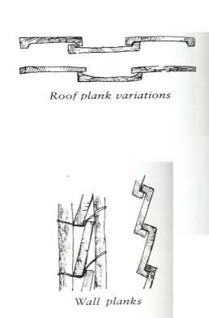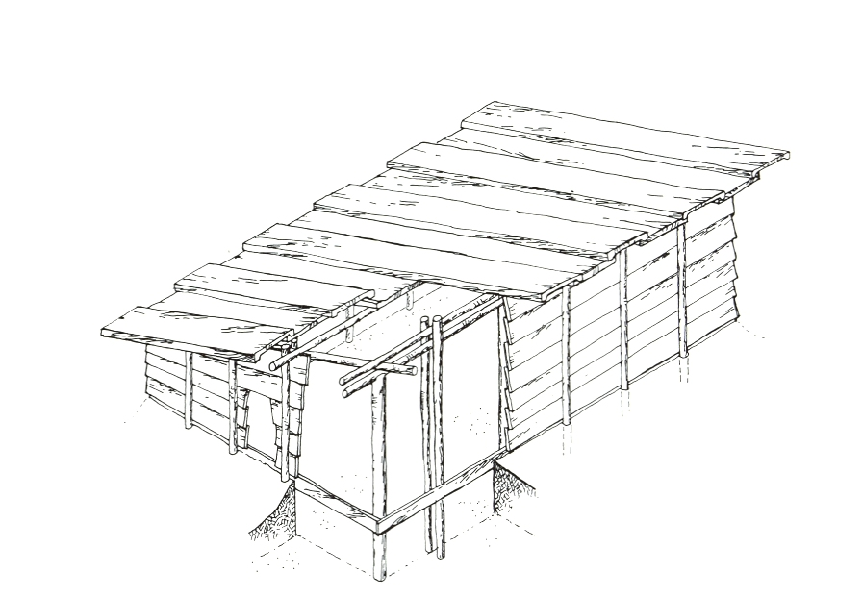
Drawing of a traditional plankhouse showing construction technique to the left.

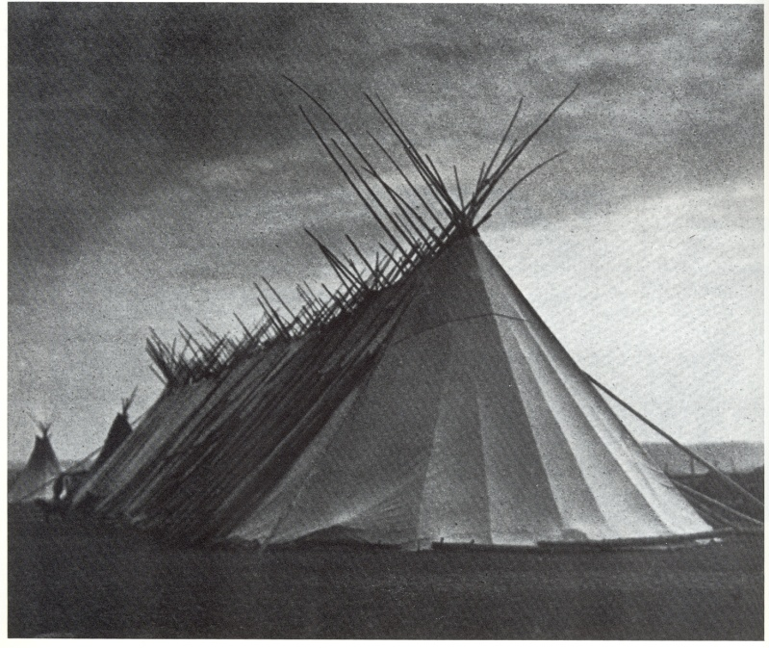
Central picture of traditional longhouse.

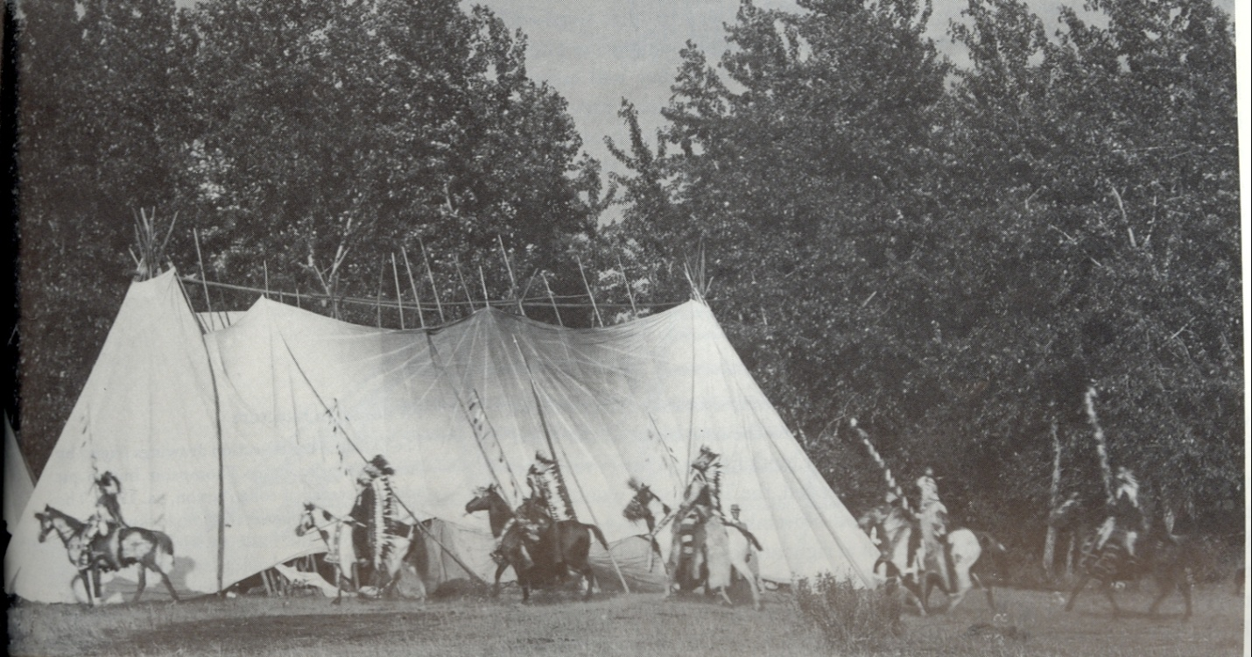
Picture of side view of traditional longhouse.

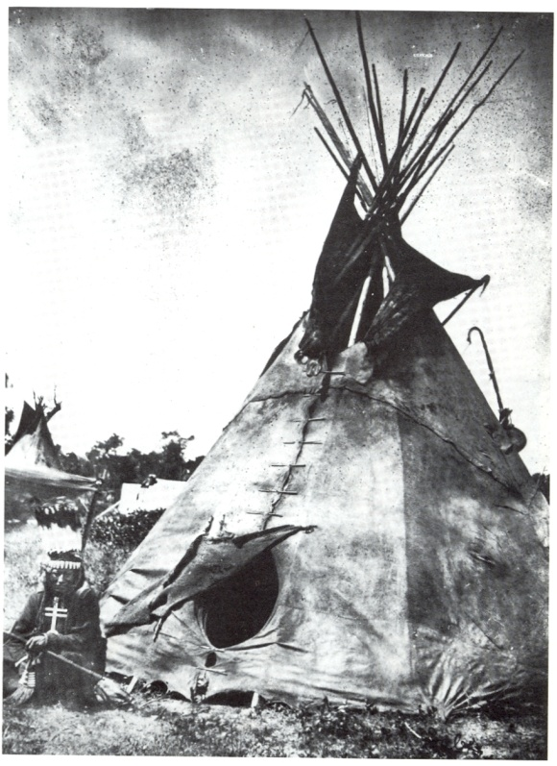
Picture of traditional tipi.

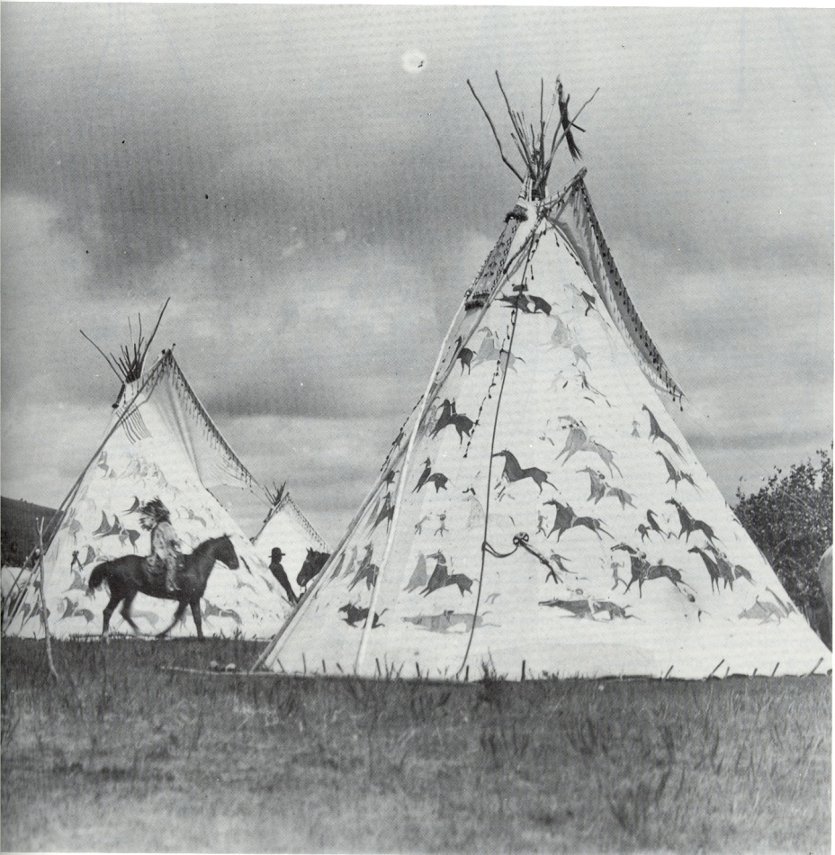
Picture of traditional tipi.

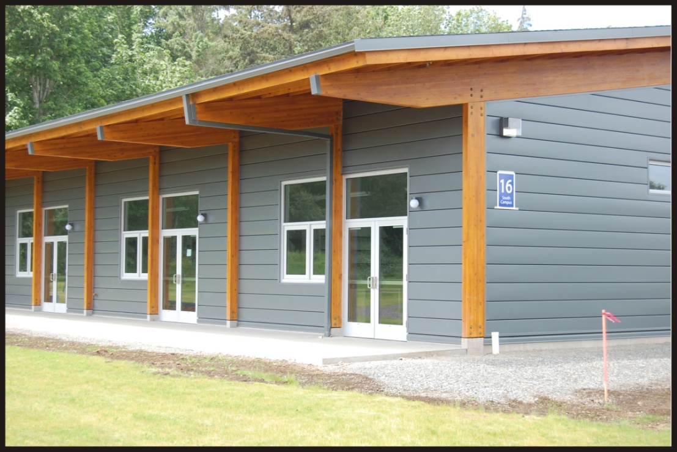
Picture of Natural Resource Lab.

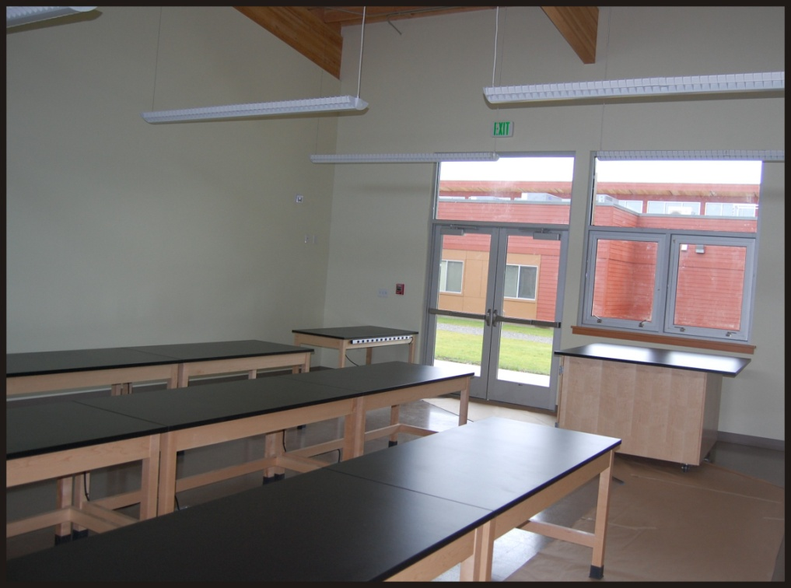
Picture of NRL-daylight views

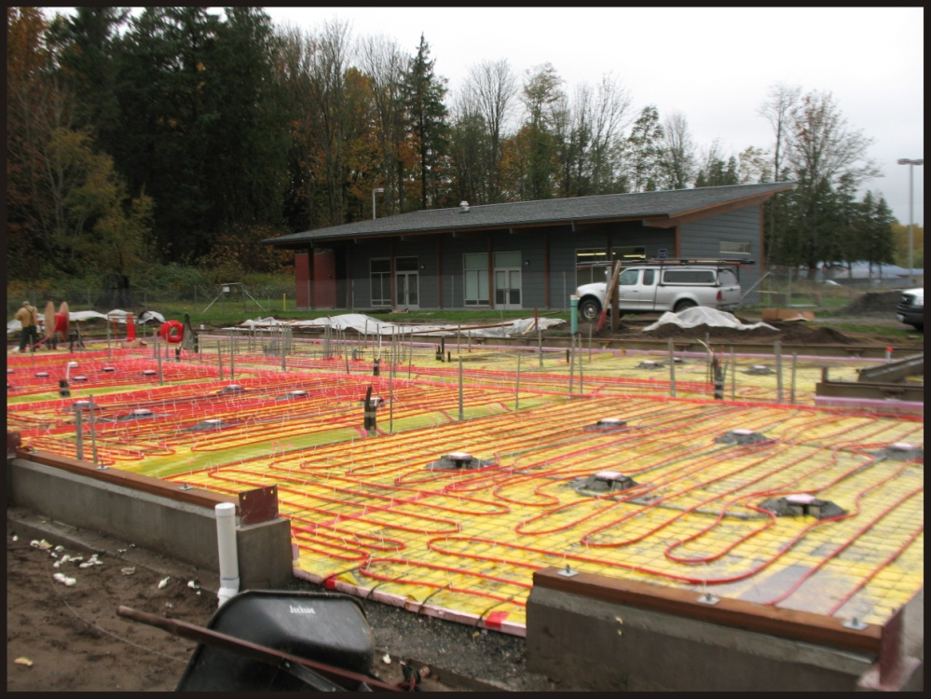
Picture of NRL-radiant floor heating.

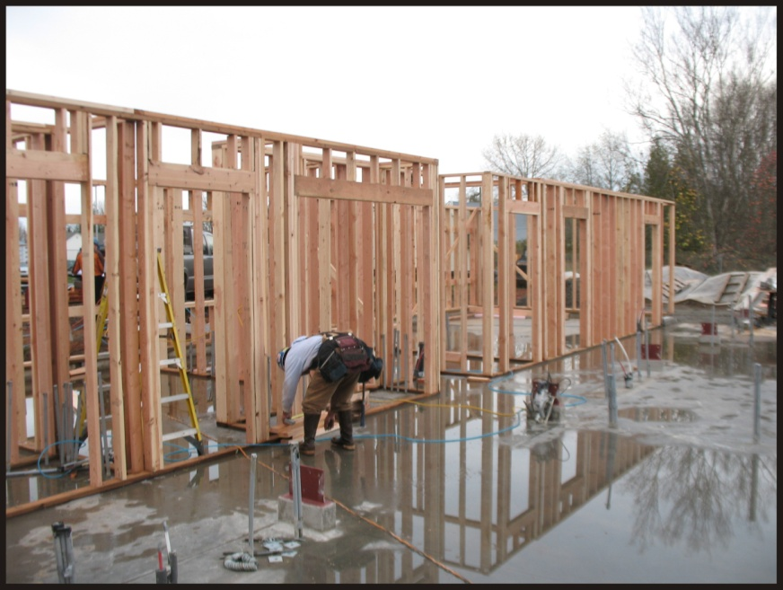
Picture of NRL-foundation using FSC certified wood.

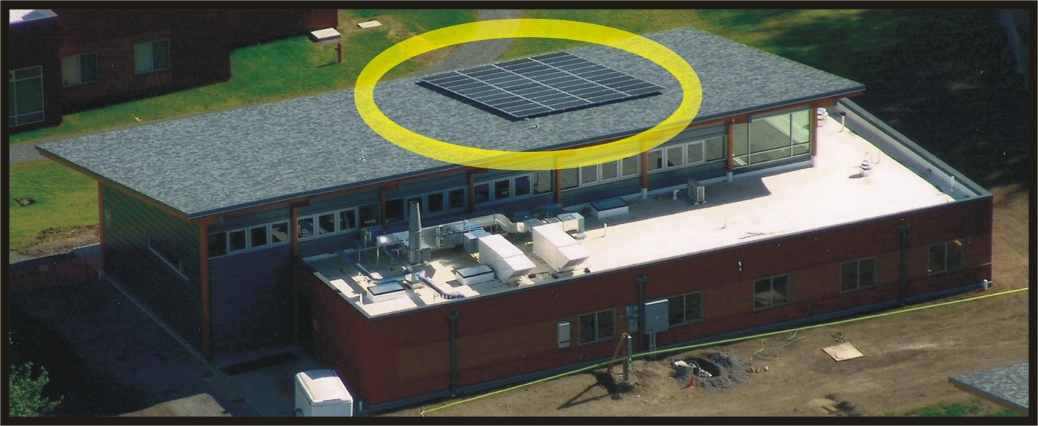
Picture of NRL-solar panels highlighted.

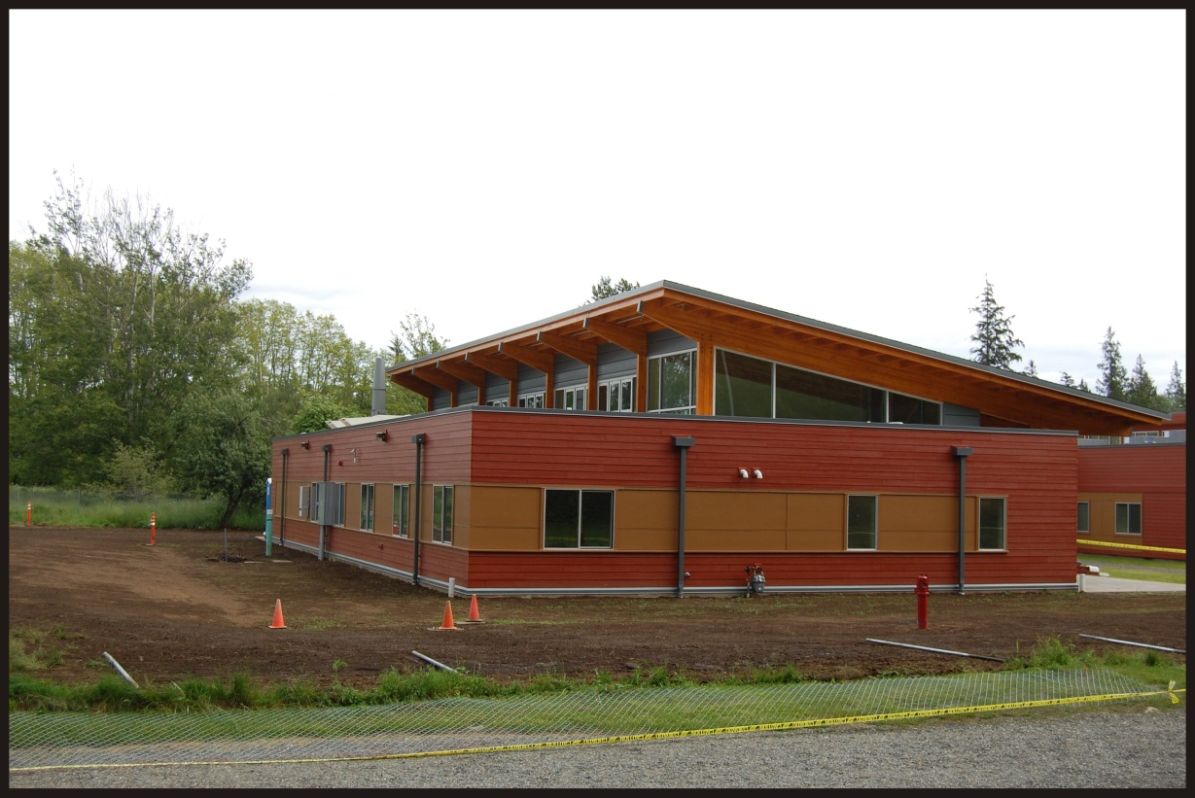
Picture of Natural Resource Lab.

